**IST 664 – Natural Language Processing**

**Instructor: Dr. Lu Xiao**

**Homework 4: Corpus Statistics and Python Programming**

**04/28/2017**

Contents

Understanding the data 2

Encoding 4

Escape Characters 5

Tokenizing the final text 6

Sentiment Analysis 8

Training and Testing sets 9

Features 9

Unigrams 10

Bigrams 11

Stop words 14

Punctuations : Count ? and ! 15

Remove Punctuations 17

Adjective Polarity 17

Word Polarity 19

Noun Polarity 20

Comparison 21

Combining features 21

Unigram and Stop words 22

Bigrams and Noun Polarity 23

Bigrams and Word Polarity 23

Bigrams and Adjective Polarity 24

Stop words and remove punctuations 24

Unigrams, Stop words and Remove punctuation 25

Final Classifier 25

# Understanding the data

I went through the discussion page (Link that was provided in the assignment instructions) and spent a little time trying to figure how the format. It is different from traditional discussion pages. Each comment is a bullet point within the box of a particular article.

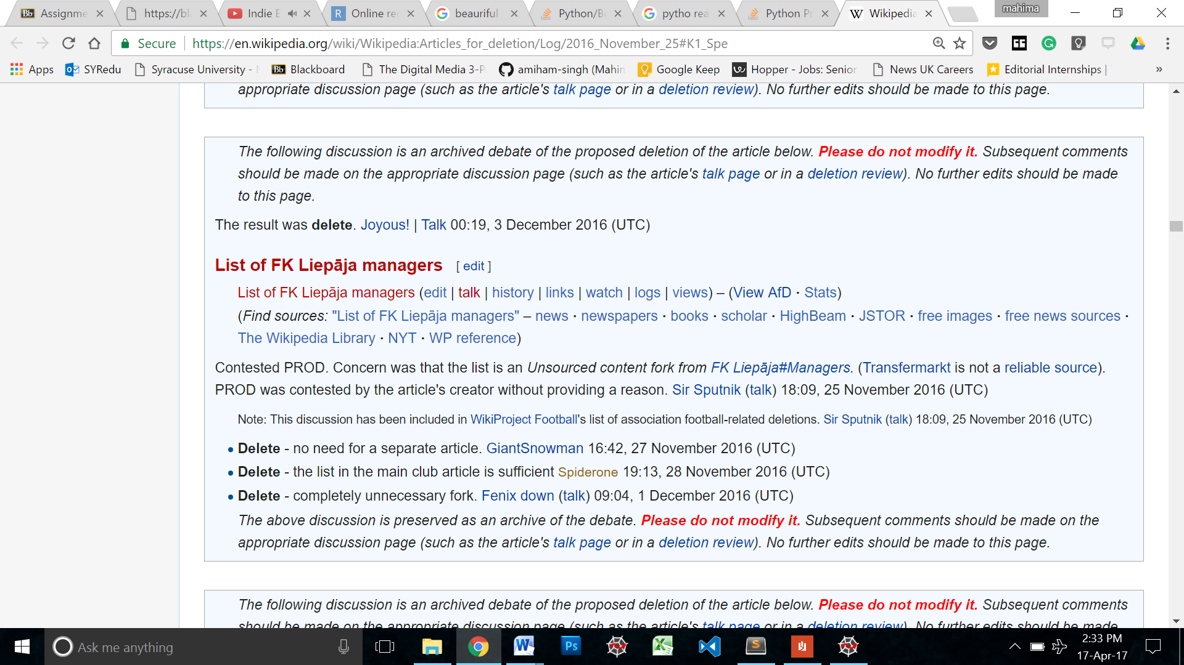

Then I looked at the text file to get a sense of the data.

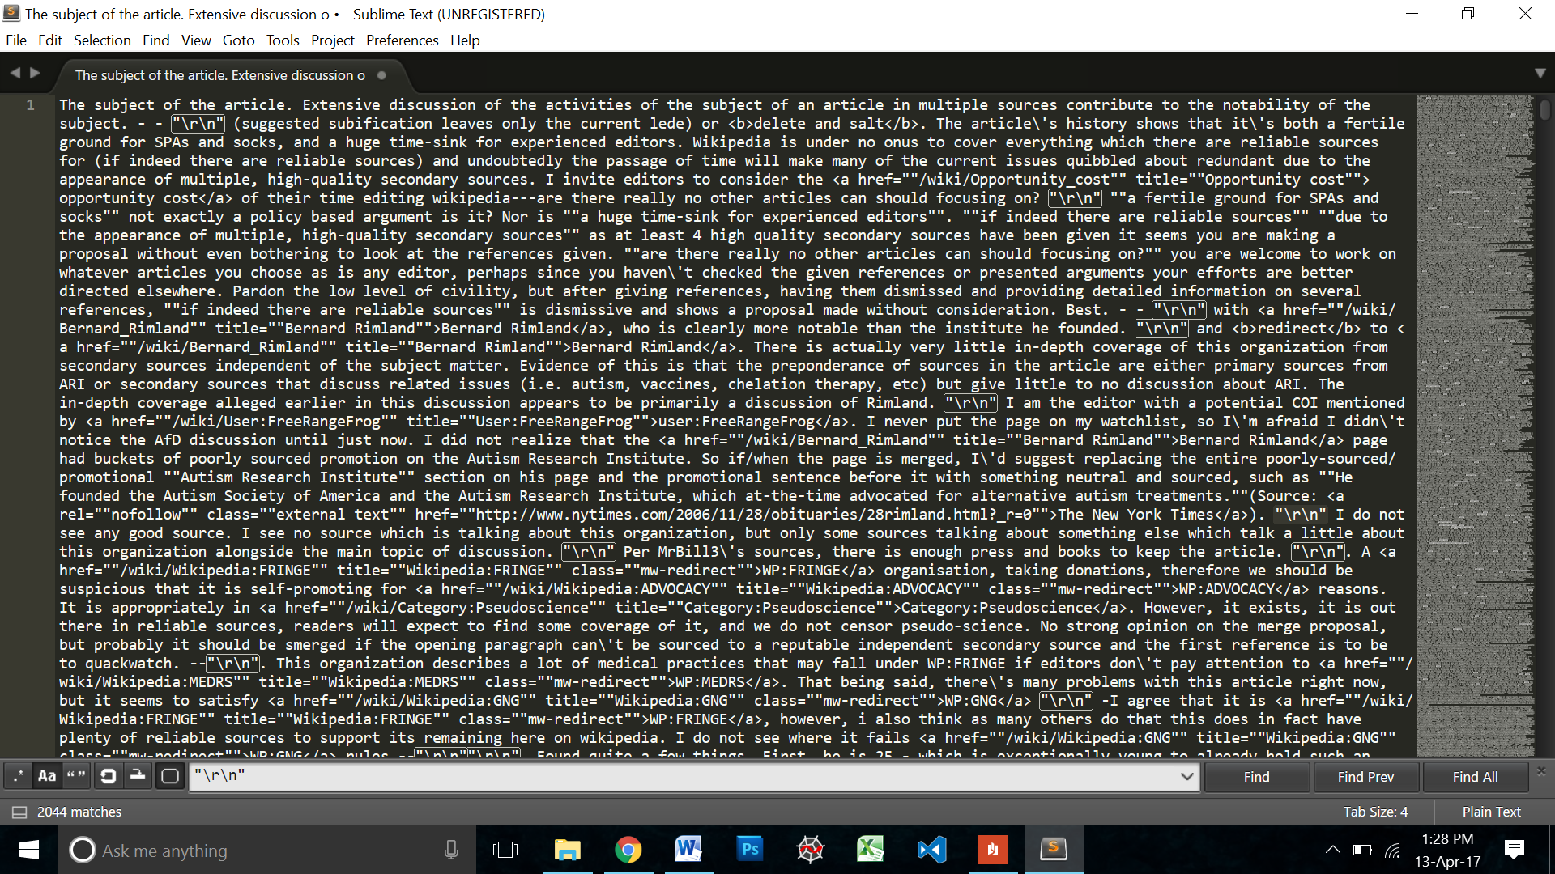

Preliminary analysis of the data:

* Maybe "\r\n" separates the individual entries in the discussion.
* The text has HTML tags especially the href tag.
* The conversion seems civilized and grammatically intact. This could mean that we ca lowercase all the words and not lose out on context. That’s great vs. that’s GREAT
* There is a high frequency of words with a slash in them.. can\'t there\'s….. looks like the text is trying to escape the apostrophe.

First I decided to strip the text of the HTML so that I can then concentrate on the rest of the text. For this, I used beautiful soup. I imported the Beautiful soup module from bs4 then I opened the original text file, read it into a string variable then converted that text element into a soup object. After which I simply ran the *soup.get_text()* function on it to all the text without the HTML tags.

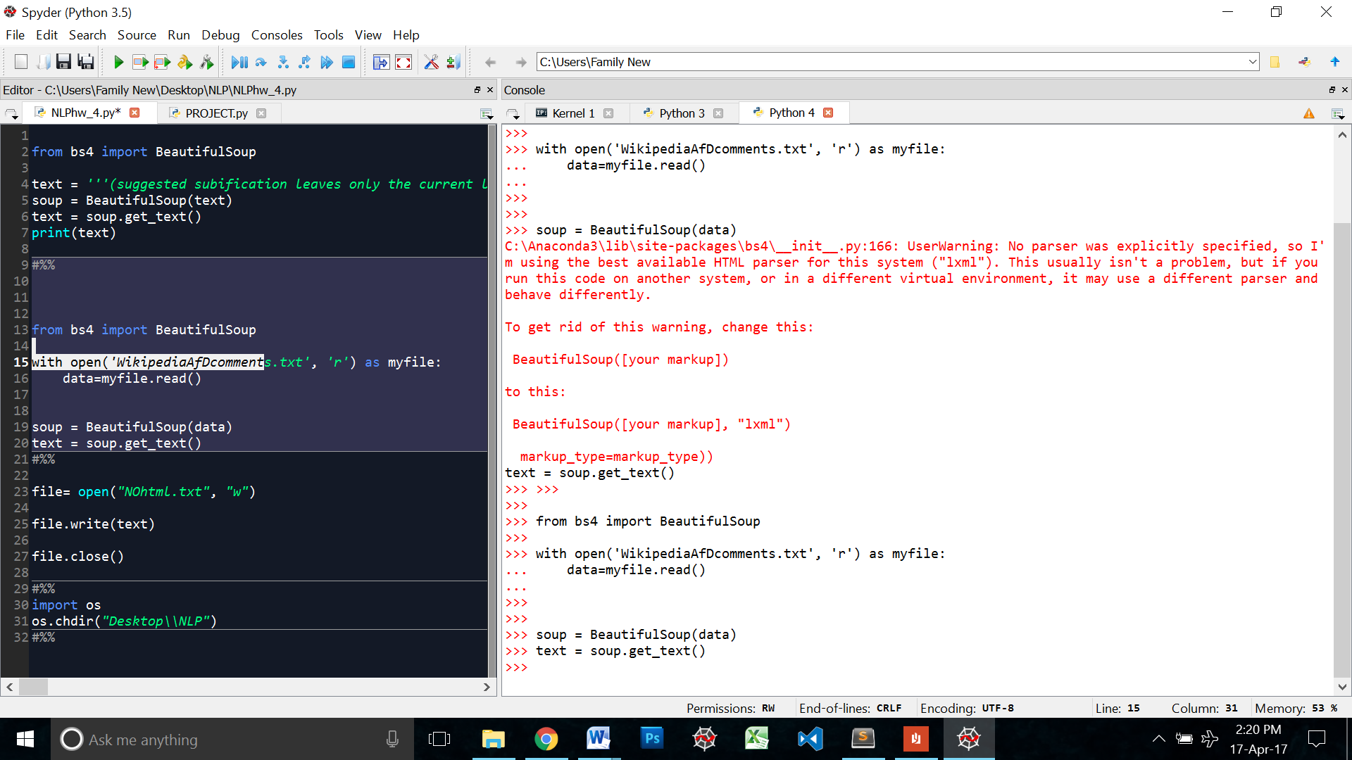

Then I wrote the cleaned text into a new file so that I could look at it as a whole.

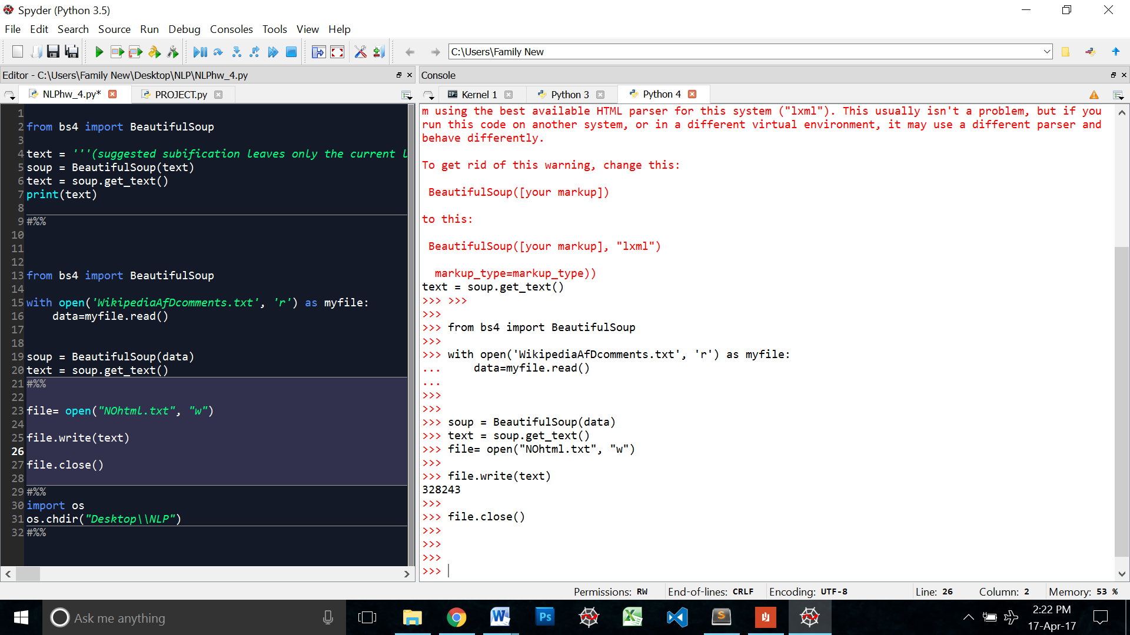

# Encoding

There were several encoding issues and I spend a lot of time trying to figure it out. Text like “\xc2\xa7"\r\n"\xe2\u20ac\u201dI\” was not being read by python properly.

I tried opening the original files in a different encoding.

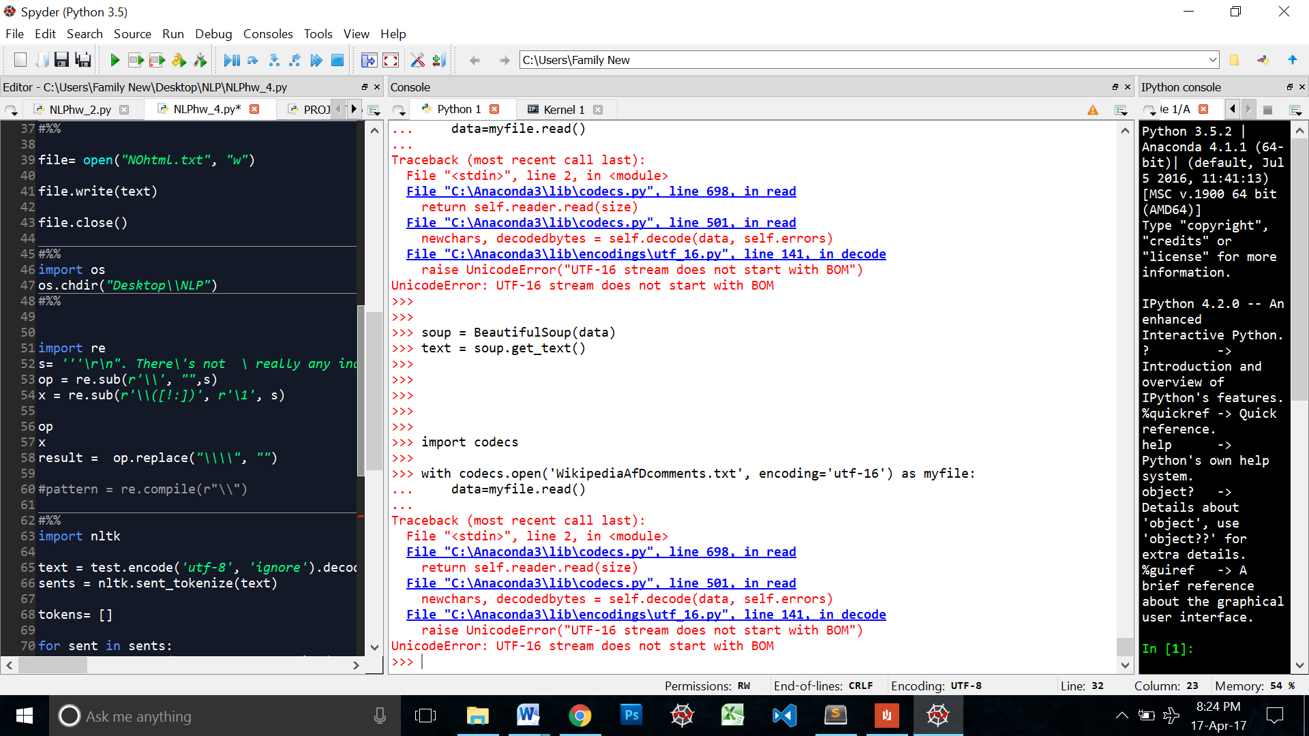

That didn’t work. Even when I tried to open the NOhtml file, there weres the same encoding discrepancies and the read file was adding extra escape characters to the text.

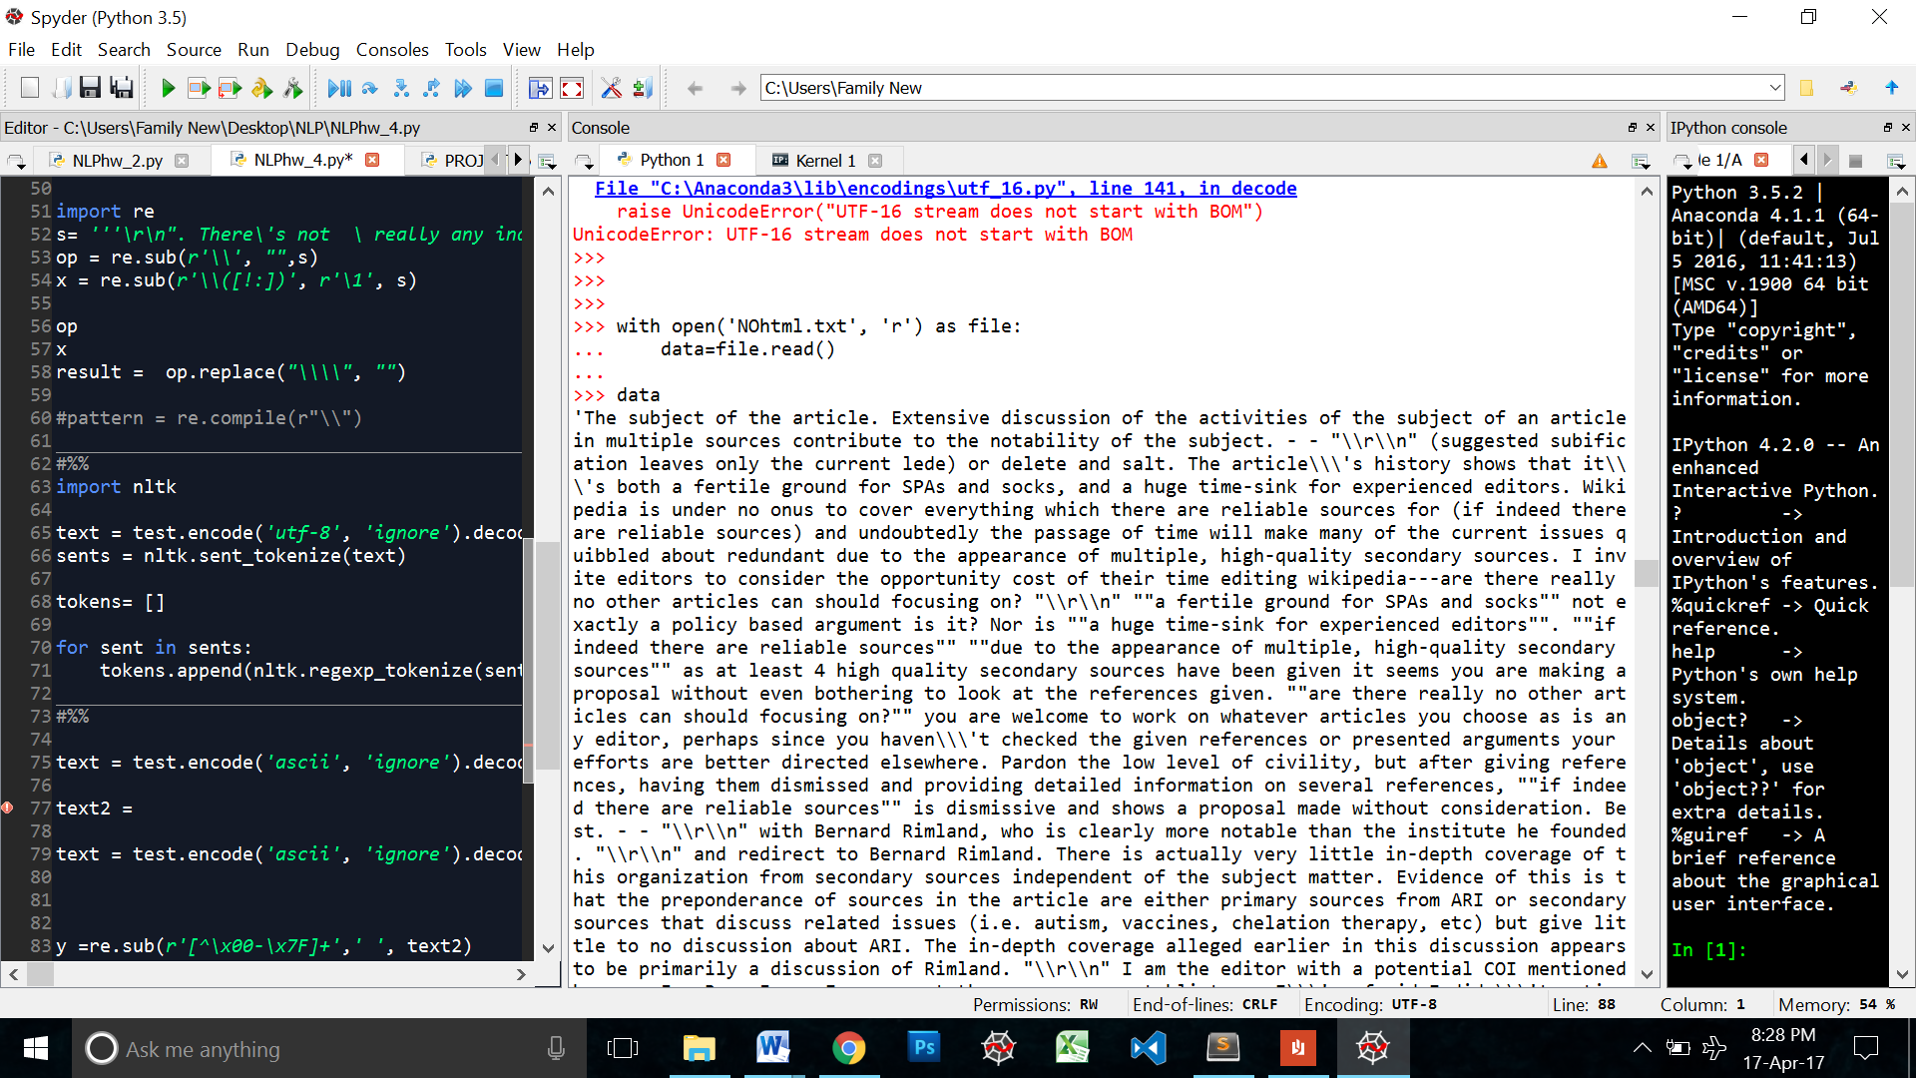

I did some online research and found that there is Mac to windows coding issue. While there were some ways to fix it online, I don’t have enough python knowledge to execute some of those. The easiest and fastest way to solve this problem (that took me days to try and figure out) was to manually copy all the test in the NOhtml file and put it in a string variable. The issue, I figured, was with python’s I/O process.

So I copy pasted the entire text into a variable called ***text***

Now, I had my text without any pre-embedded coding. While the xe2\u20ac\u201dI\ words were still there, I could then manually encode the ***text***file. Here I experimented with ASCII and utf-8 encoding.

**text.encode(ASCII', 'ignore').decode(ASCII')** worked well It got rid of all the xe2\u20ac\u201dI\ words.

# Escape Characters

After experimenting with many regex cleaners and tokenizers, I realized that the escape characters were only in the representational form of the text.

I took a subsection of the data and gave it a variable name to experiment with. After I printed the text I realized all the escape characters weren’t there anymore.

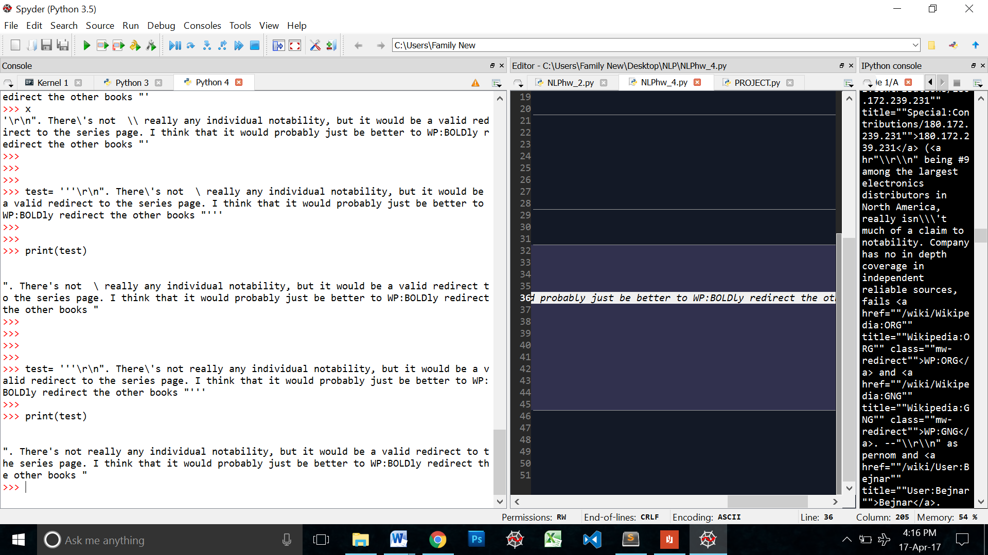

But what did this mean for my tokens?

I tried tokenizing the test to see the results

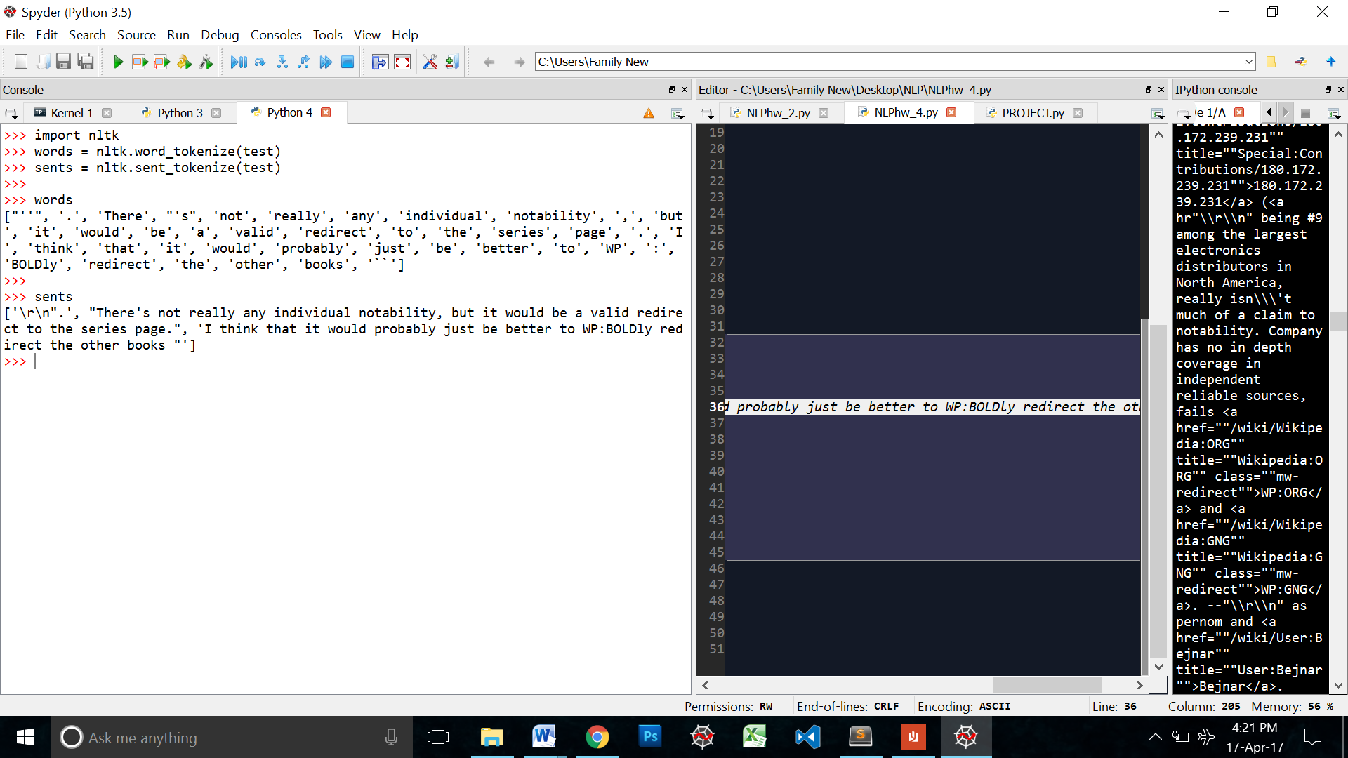

While at the world level the tokens seemed ok. The sentence level tokens still had the “\r\n”

So I went a level deeper by further tokenizing the sentence level tokens

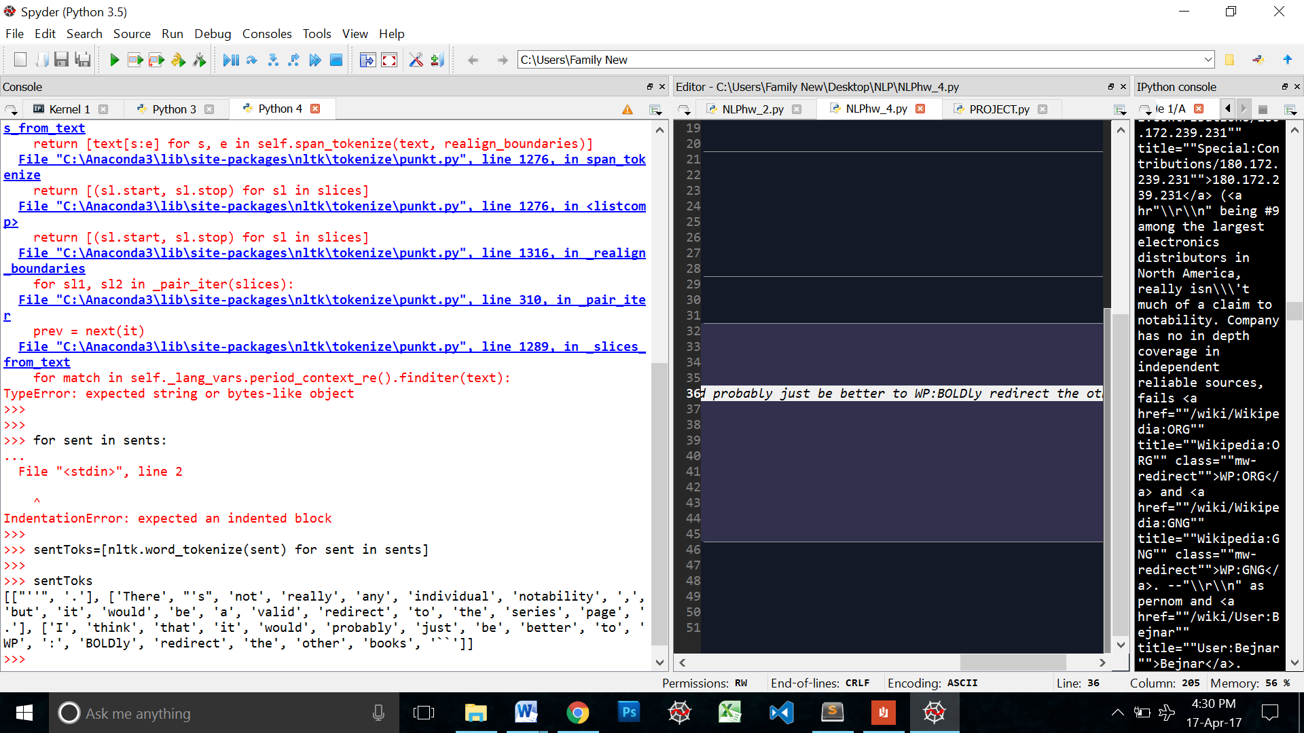

It looked good. So I decided not to forcefully remove the escape characters.

# Tokenizing the final text

Finally, reaching this step in the assignment, I first tokenized the text at the sentence level then I used a regex tokenizer to tokenize the sentences further.

Regex: nltk.regexp_tokenize(text, r'[?!]|[a-zA-Z]+[\'.][a-zA-Z]+|[a-zA-Z]+')

This matches:

* All alphabetical words
* Words with the apostrophe inside them – it’s can’t there’s
* Hyphenated words
* Words with full stops inside them – Ph.D. i.e. e.g.
* The punctuations: ? ! [ I want to test if the exclamation mark and the question mark have anything to do with sentiment]

I converted all the text to lowercase then I ran it through the sent tokenizer

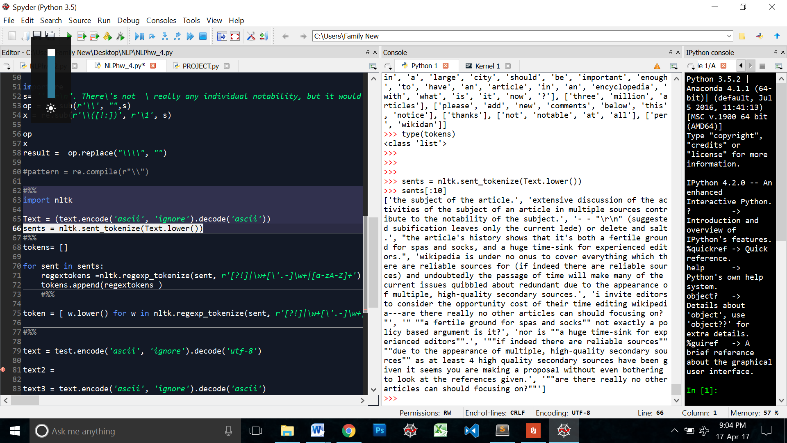

Then I ran each sentence through the regex tokenizer and obtained the tokens list.

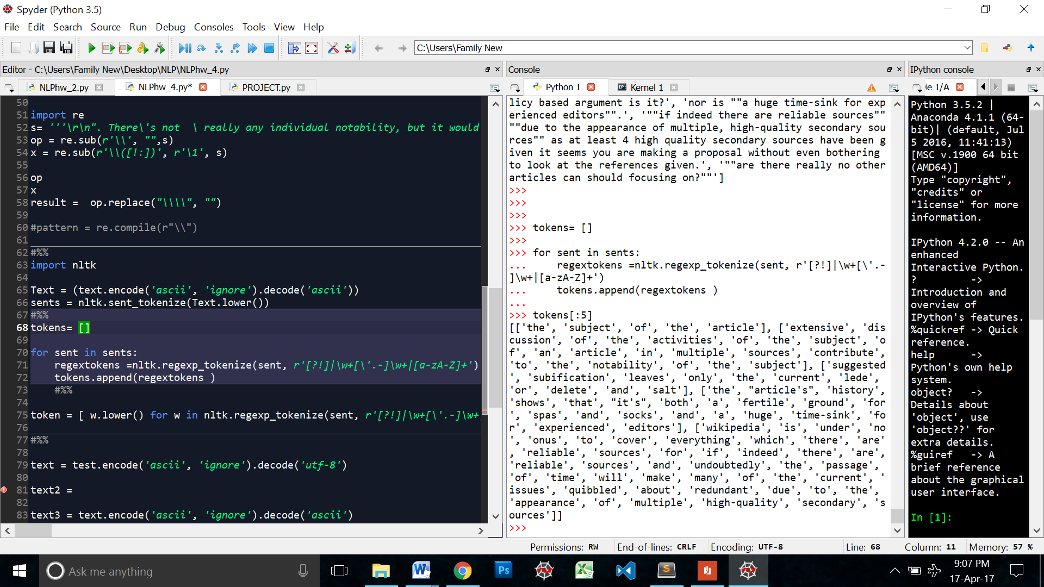

Though we will not be using the tokens directly while classifying the text in the final steps of this project, I did this to look at my tokens to see if there are any problems in the tokenization process S the above figure indicates, there doesn’t seem to be any problem.

I also checked the total number of sentences.

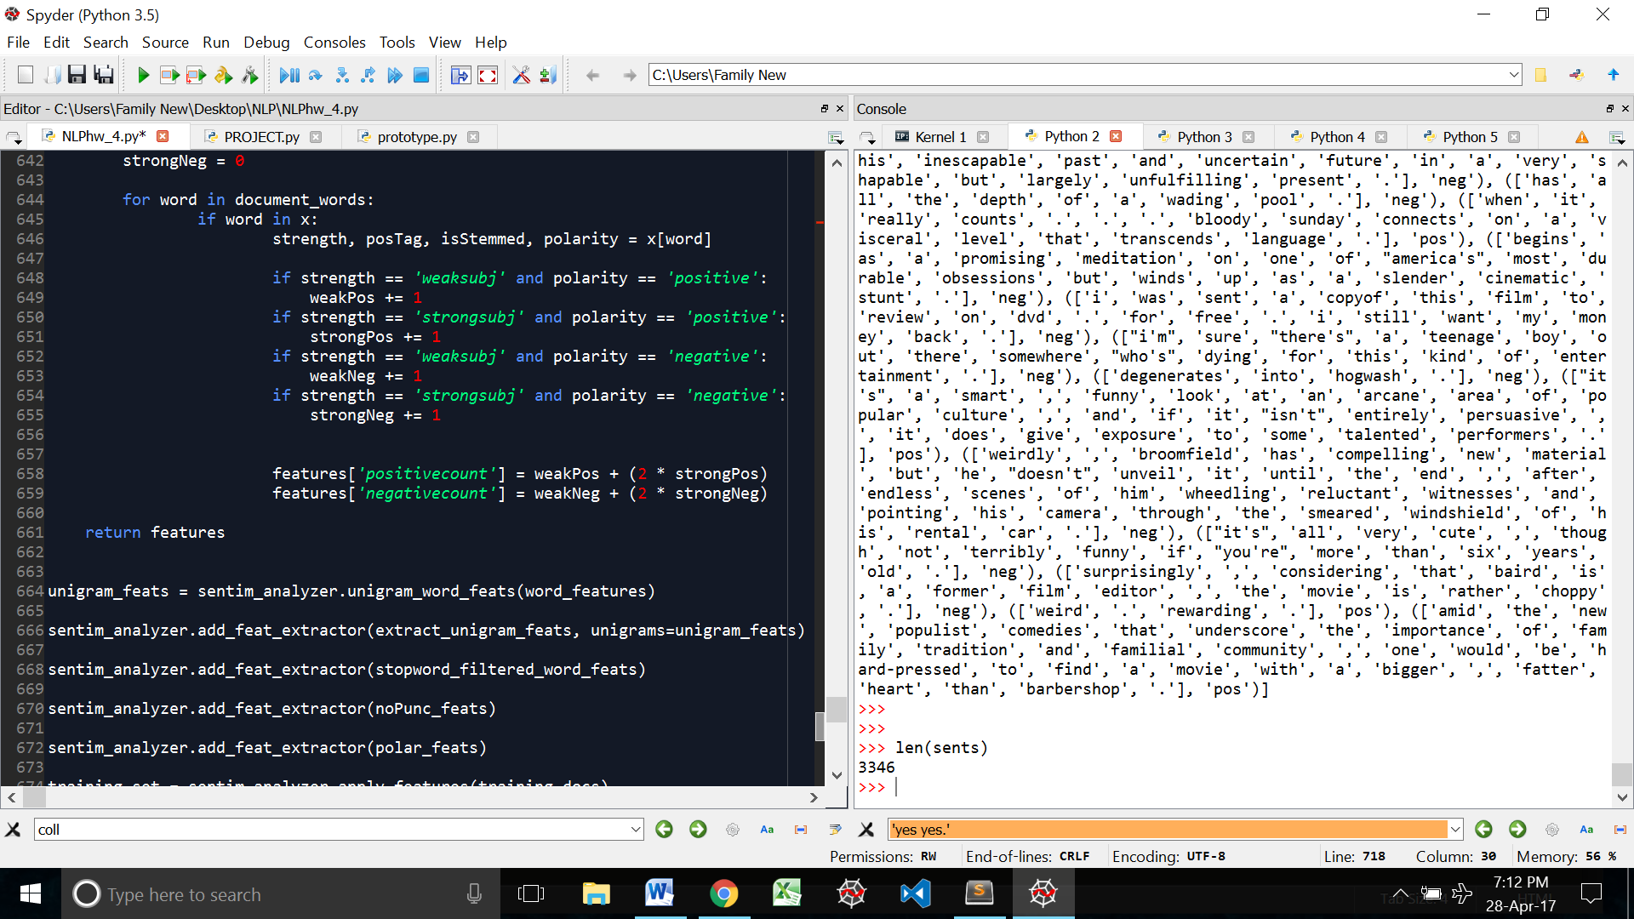

# Sentiment Analysis

Now that I have my tokens I can move on to the sentiment analysis part. For this part, I will be using NLTK’s sentiment analyzer module and the NaiveBayesClassifier. I chose the sentiment analyzer module because it has built in modules to calculate precision, recall, f measure etc. all at once. It also allows us to add multiple features to a classifier quite easily.

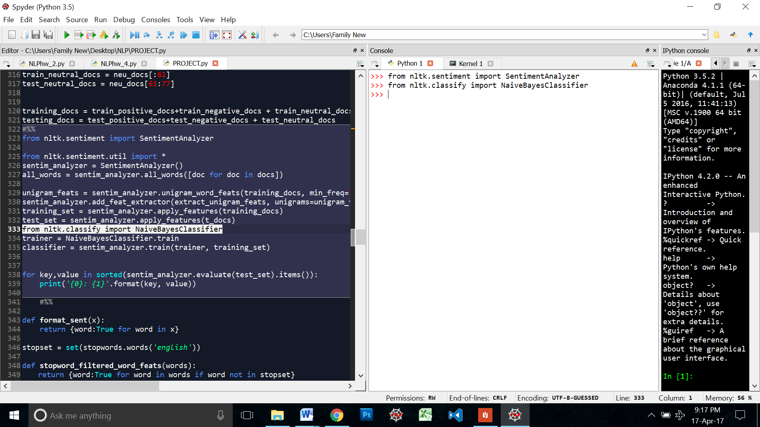

I will now use the sentence_polarity corpus to train my models and then run my new token through this model. The problem I foresee with this is the possibility of new words appearing in the wiki discussion page that isn't in the corpus. According to me, it would be better if I manually looked at a subset the sentences in the wiki discussion and tagged them myself. Then used this tagged set to train a model. But since NLTK already provides us with a corpus of positive and negative sentences, we will use that for now.

I imported the corpus, along with the random module so that I could shuffle the sentences around later. Then I created the list of documents where each tokenized sentence is paired with its positive or negative tag from the corpus. This will base my base.

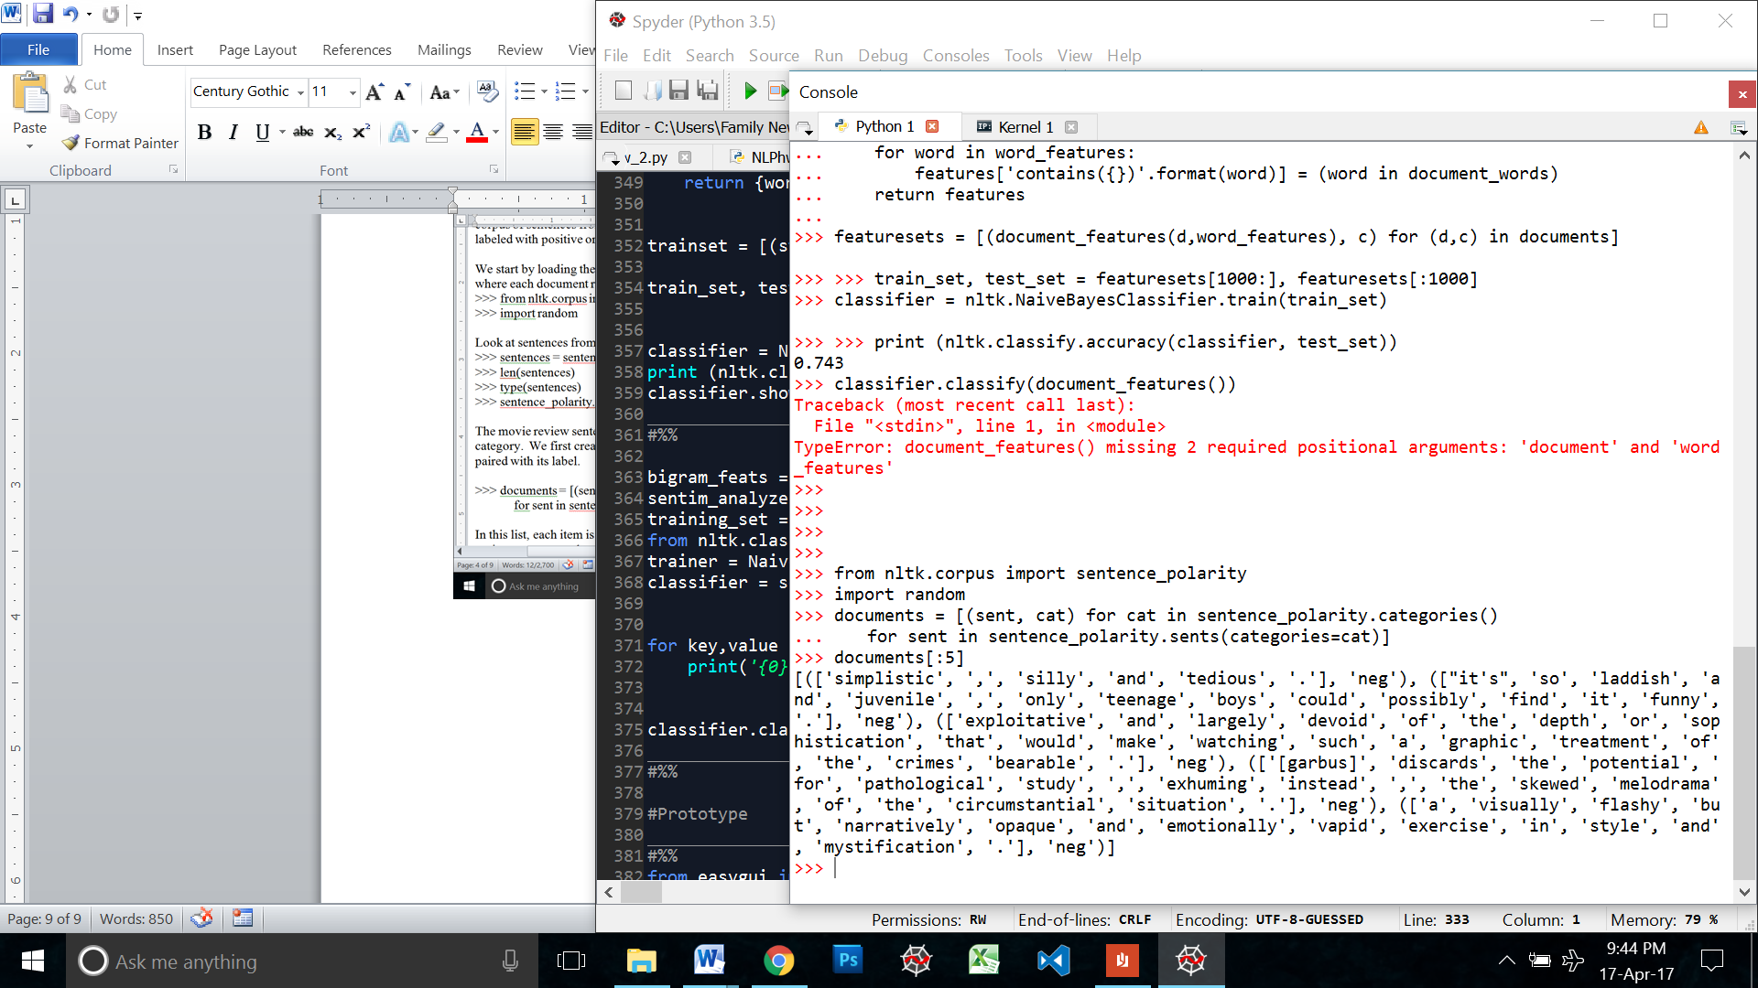

Right now all the negative tagged sentences are together and the positive ones are listed after those. We shuffle them around here to get a random list so that when we are creating our training and testing sets we don’t end up training our model only on the negative sentences.

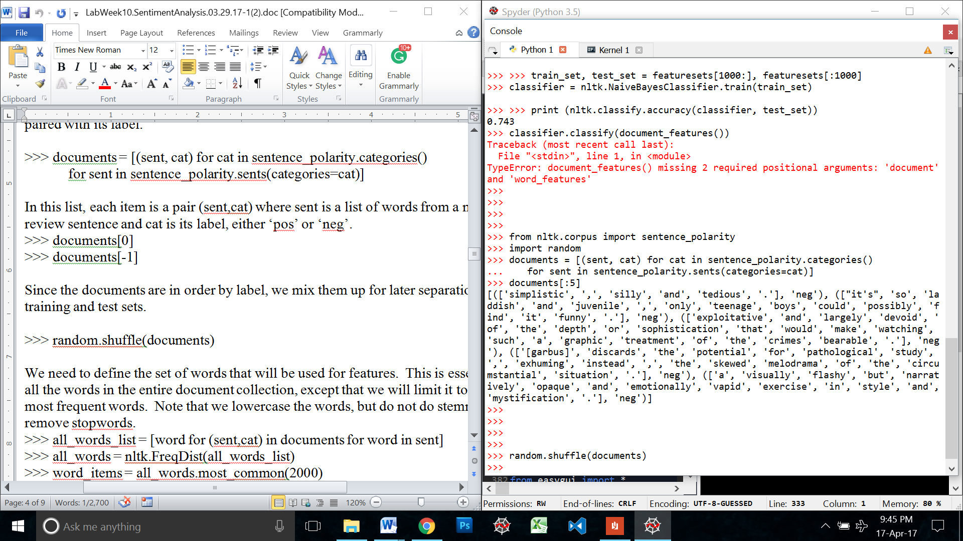

Next, I created a list of the 2000 most common words with their corresponding tags

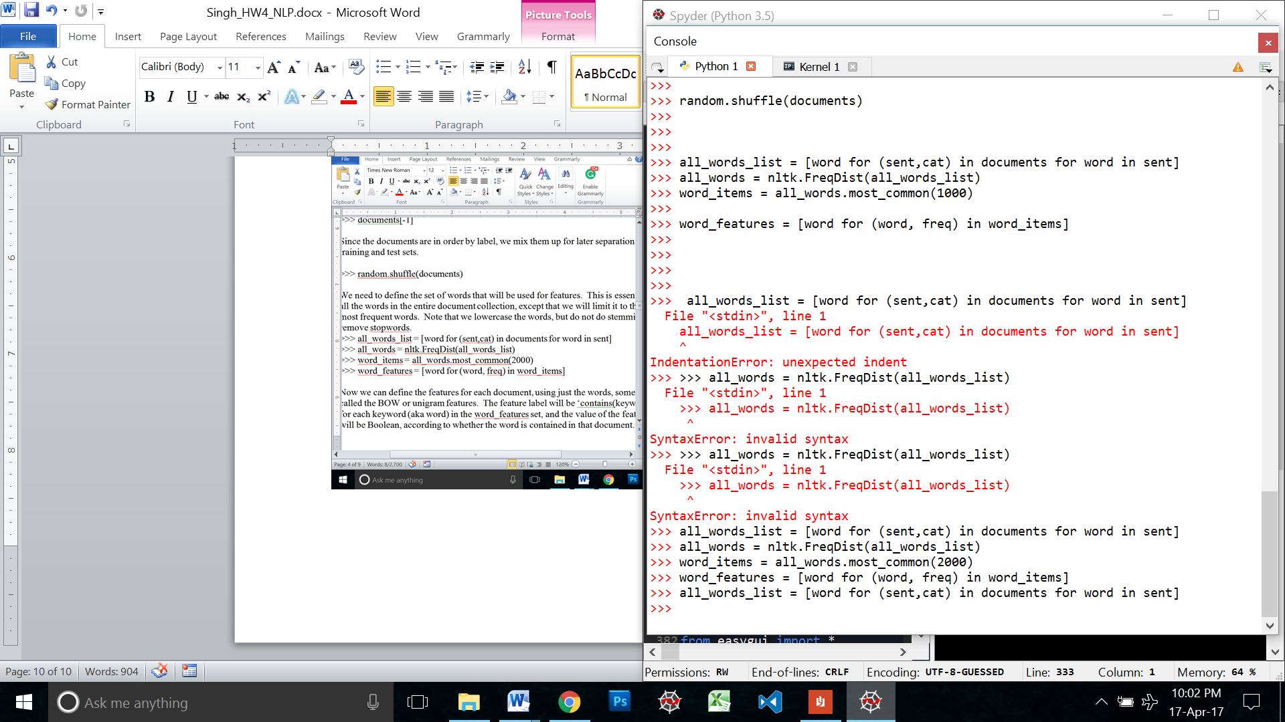

I will create features for the documents on these words

## Training and Testing sets

We first define the training and testing docs as such:

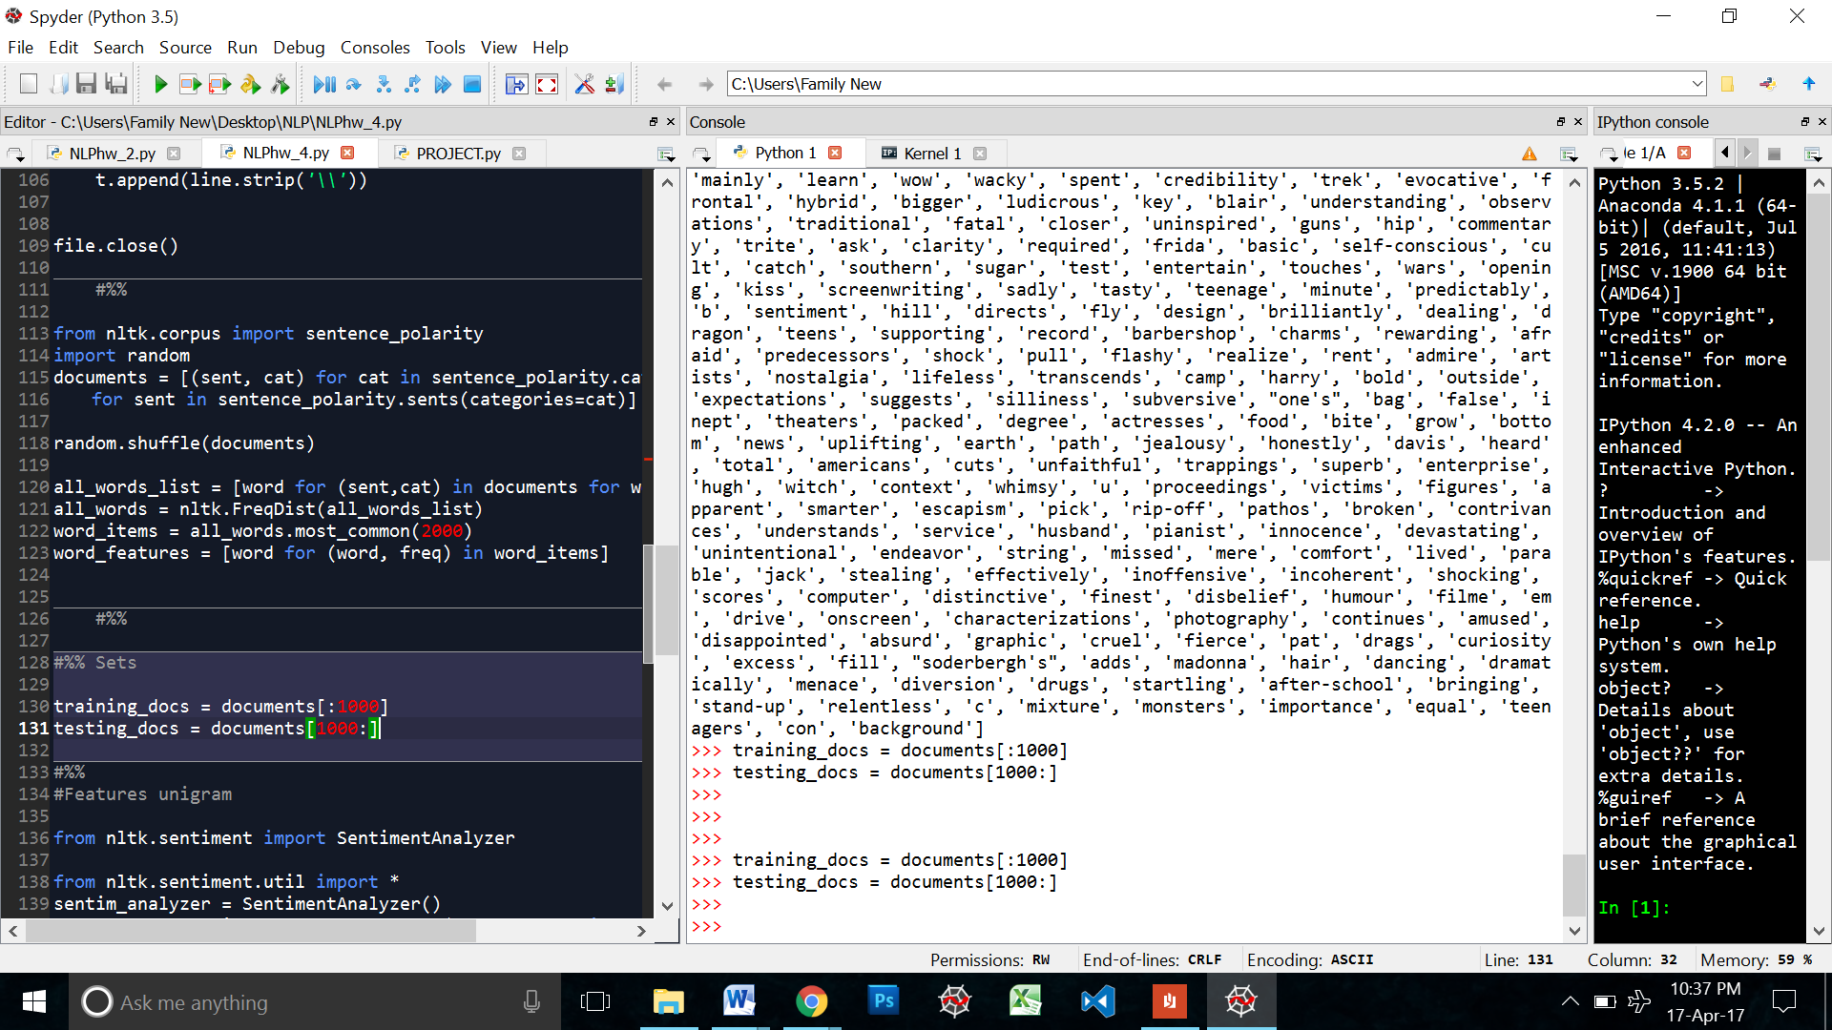

We will later apply features to these sets and train the classifier on it.

## Features

I will now create features and apply them to a NaiveBayesClassifier

I studied the sentiment analyzer documentation and it has a different way to implement a feature.

* First, we define the feature function ( that will return a dictionary of feature sets and tag)
* Then we use the *sentim_analyzer.add_feat_extractor()* function to add the feature to the analyzer. (NOTE: We can add multiple features here at the same time by calling the *add_features_exctractor* with new features function every time. Downside: If we are only experimenting with one feature set individually, we will have to create different objects of the sentiment analyzer class for each feature set. Because every time the ad_feature_fuction is called, it adds to the existing list of features in the extractor.)
* Then we apply this feature or feature sets to the training and testing set with the *sentim_analyzer.apply_features* function.
* Then we define the classifier and train it using *sentim_analyzer.train* function

Sentiment Analyzer already has unigram and bigram features built into the class. I will first test these two out.

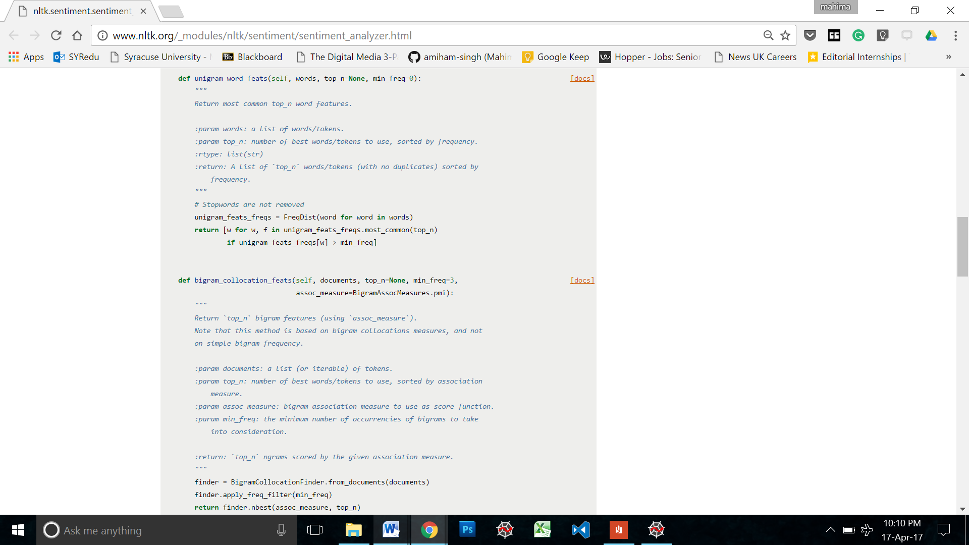

### Unigrams

Following the sets explained in the previous section, I also import *nltk.sentiment.util*

So that I can extract the unigram features from the module

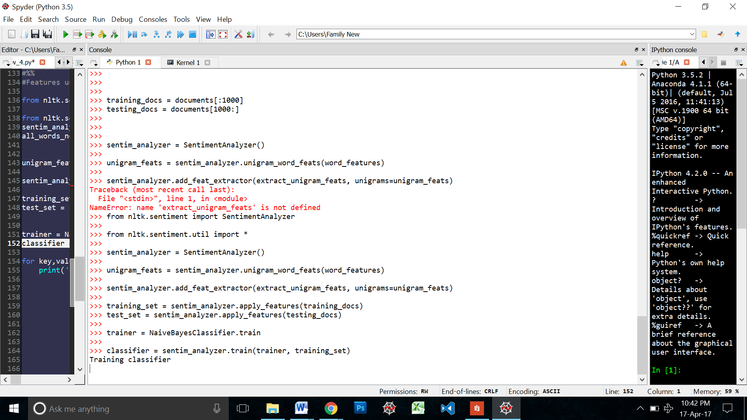

Using sentiment analyzers evaluate model we print the following results:

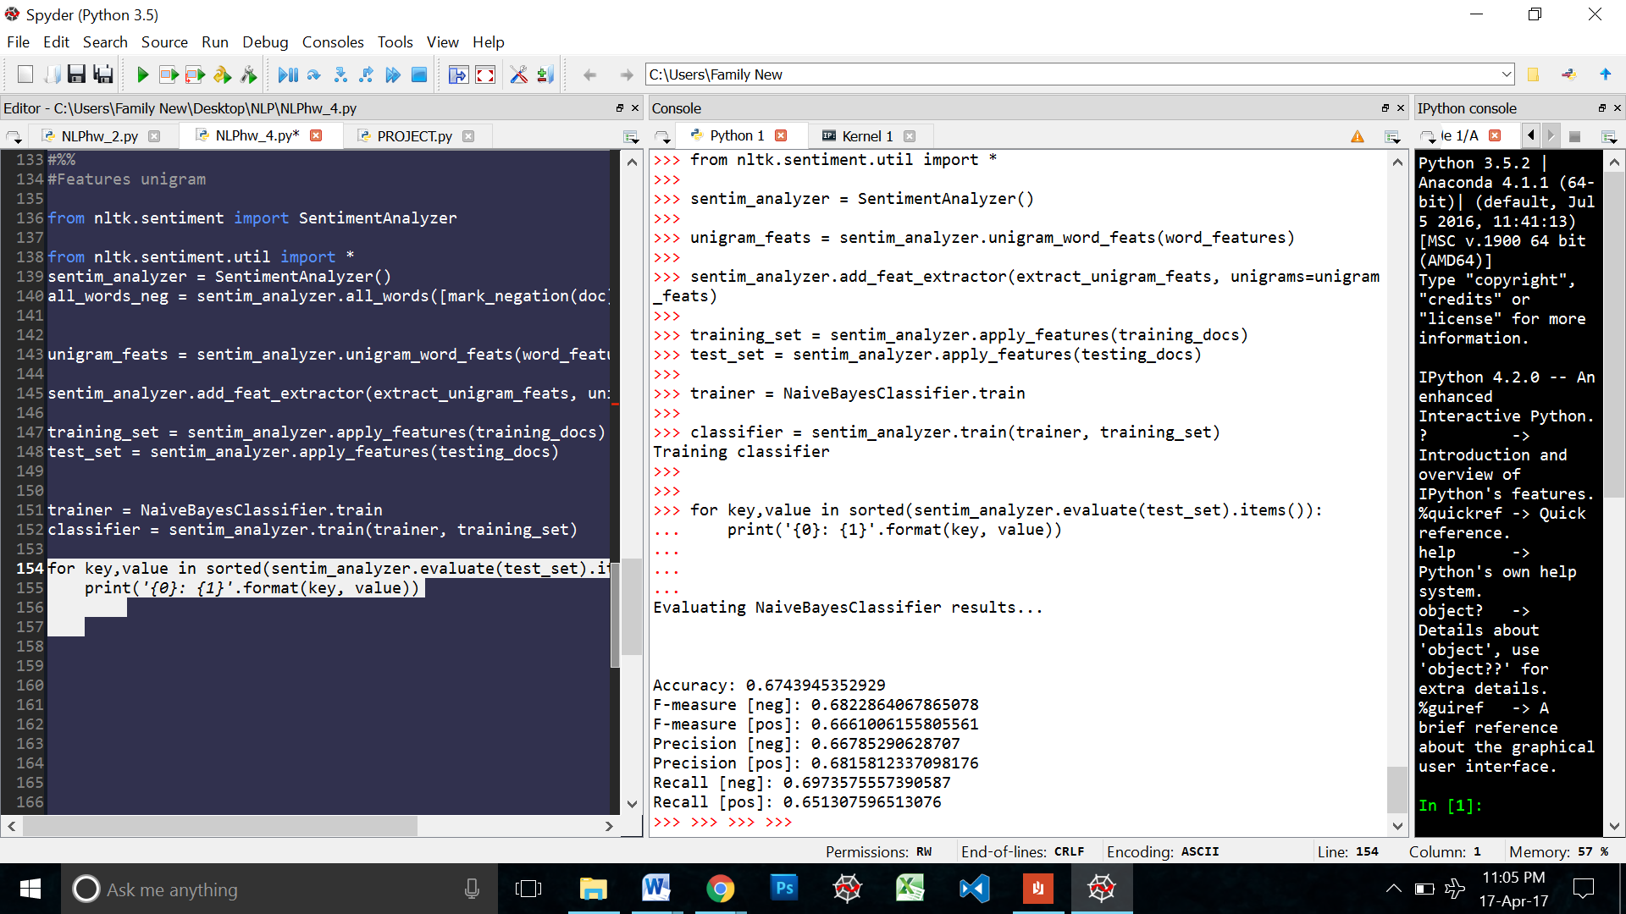

### Bigrams

The sentiment analyzer has a bigram features module a well. We similarly call it here as follows. But we have to initialize a new sentiment analyzer object for this feature specify so that we don’t add it to the unigrams feature set:  **sentim_analyzer_bi**

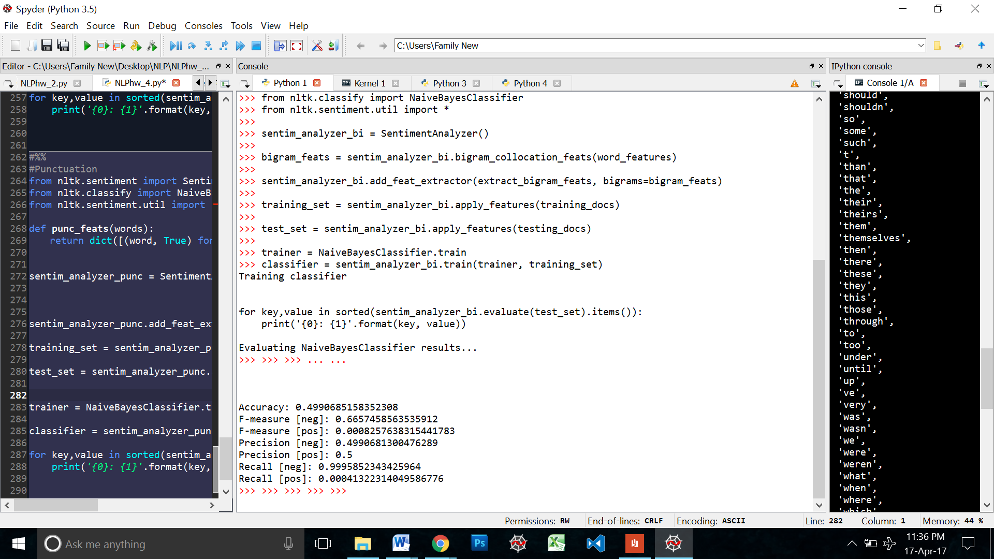

Version 2:

I didn’t know what was really happening in the predefined bigrams module of the sentiment analyzer. So just to be sure, I defined my own bigram features to get a better understanding of what was happing and to see if there was any difference between the two versions.

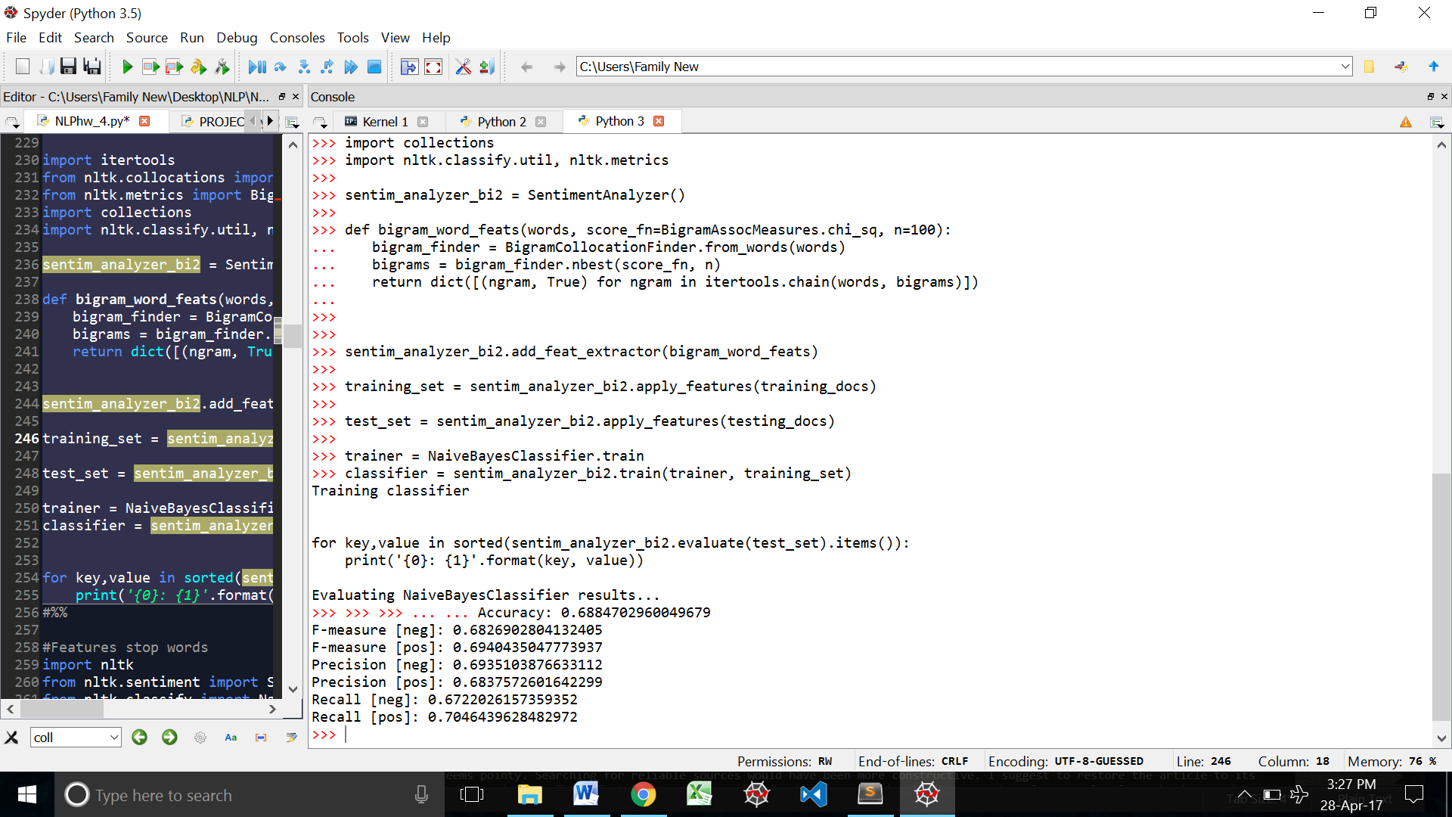

As I though this version yielded a better accuracy.

I called the Show most informative features function on both the bigram classifiers to see if there was any difference

Version 1:

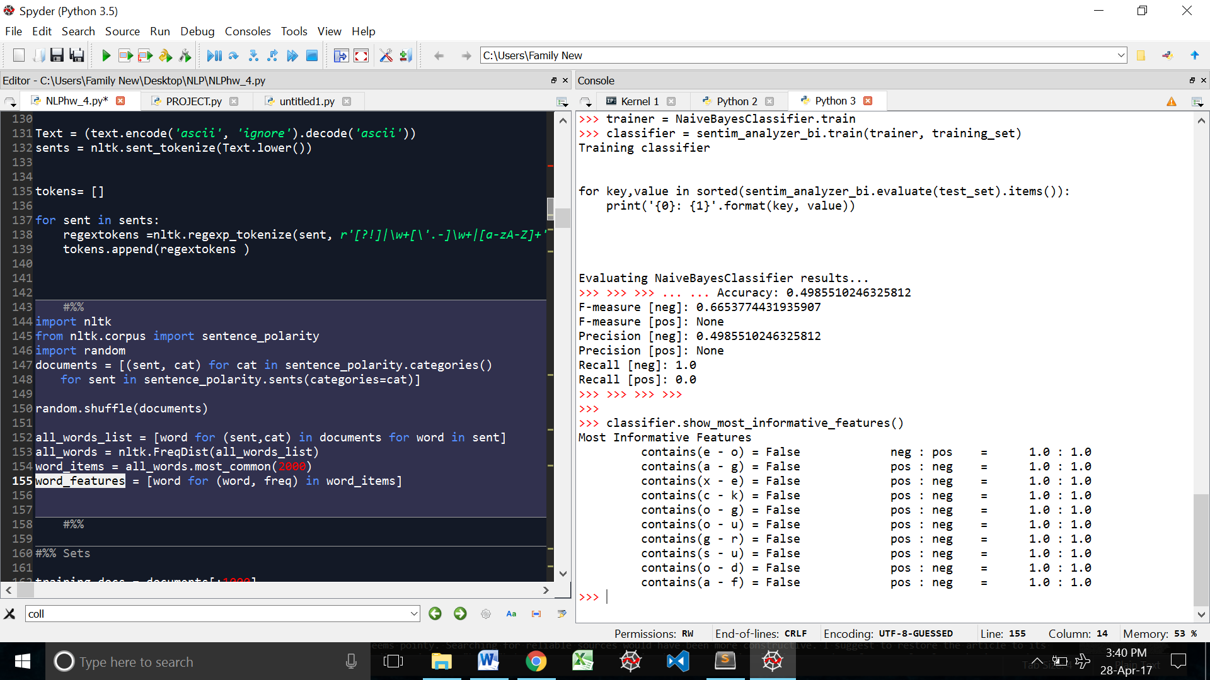

Version 2:

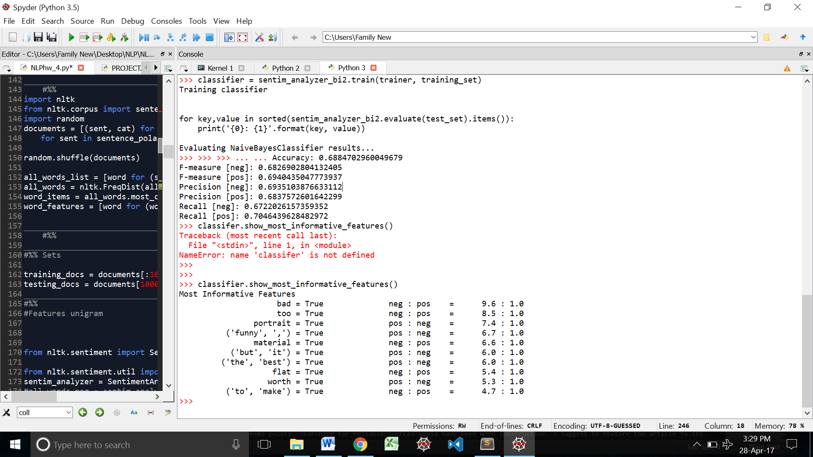

As we can see, the first version of the bigram features takes each alphabet as a word and creates bigrams based on that. The second version actually takes a whole word.

### Stop words

We define a function that removes the stop words from our word_features. Then we create another sentiment analyzer object, exclusive for this feature: **sentim_analyzer_stop**

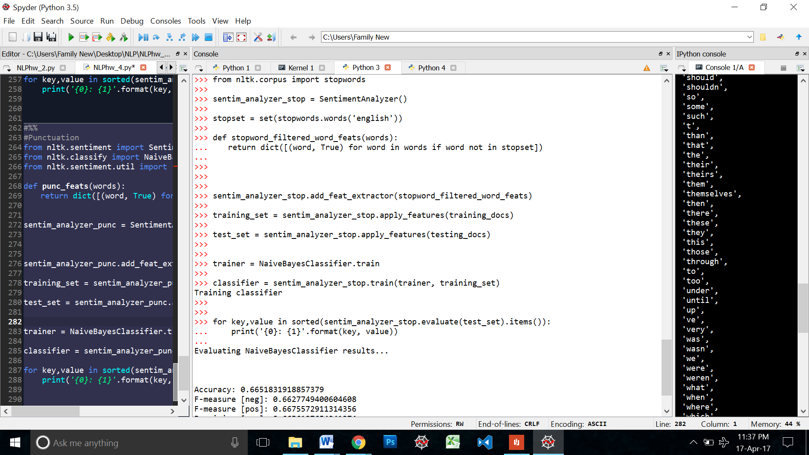

Then we evaluate this specific classifier as follows:

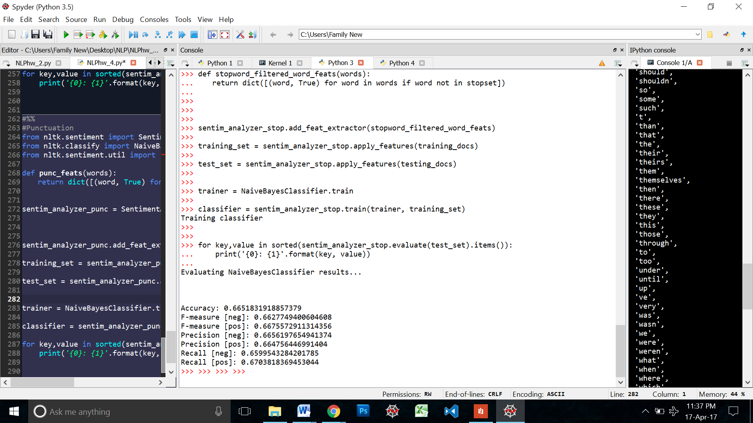

### Punctuations : Count ? and !

I wanted to see if the exclamation mark and the question mark have anything to do with sentiment. So I wrote 2 versions of this function

punc_feats(words) just returns if the sentence has a question mark or not.

punc_featse(words) returns a dictionary of the number of question marks and examinations.

Version 1:

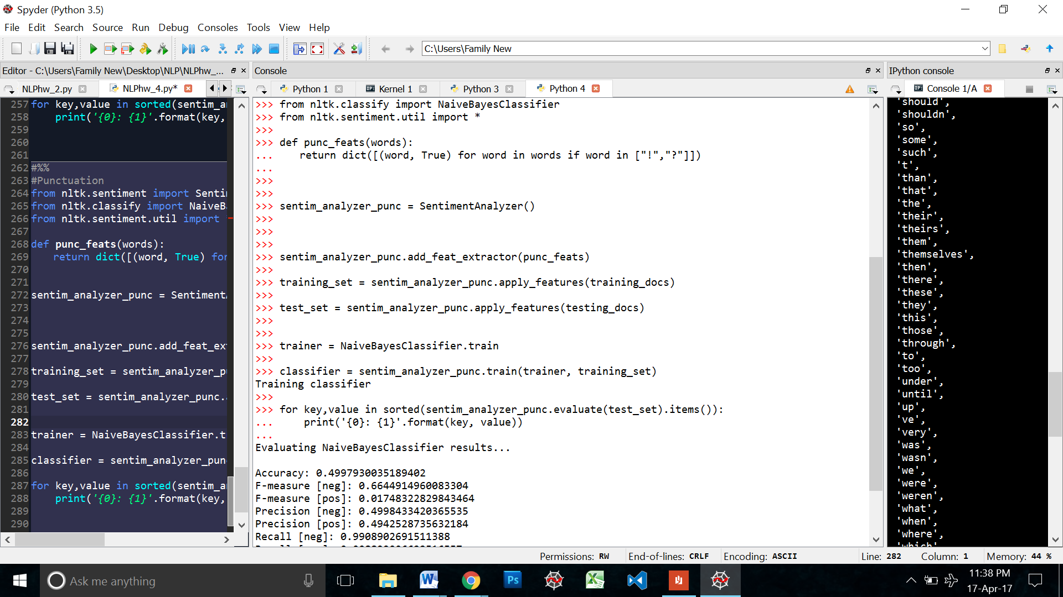

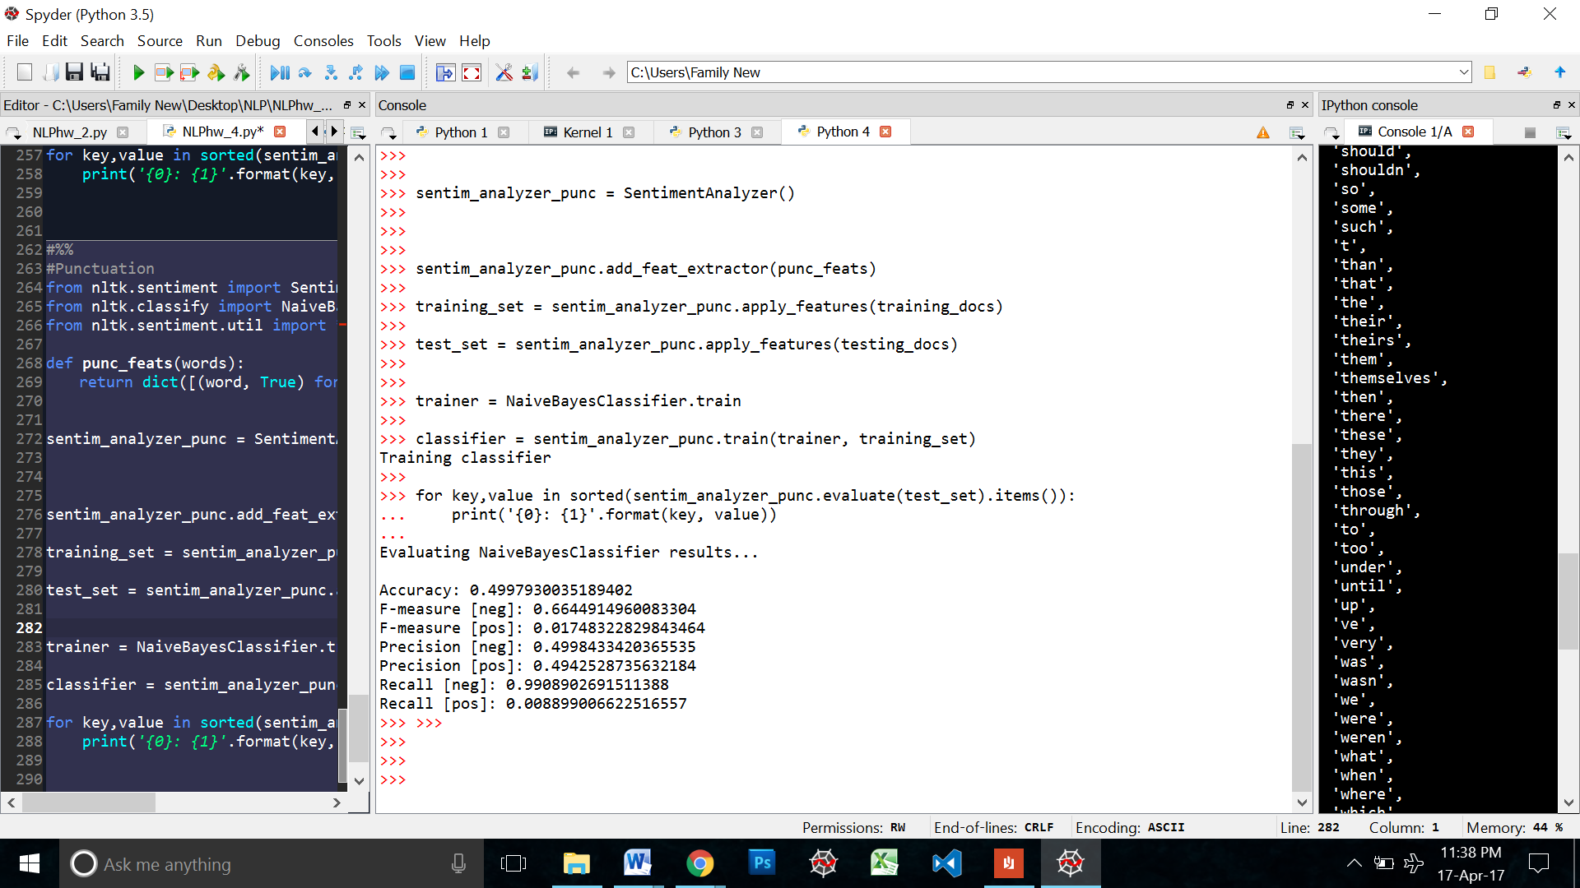

Version2:

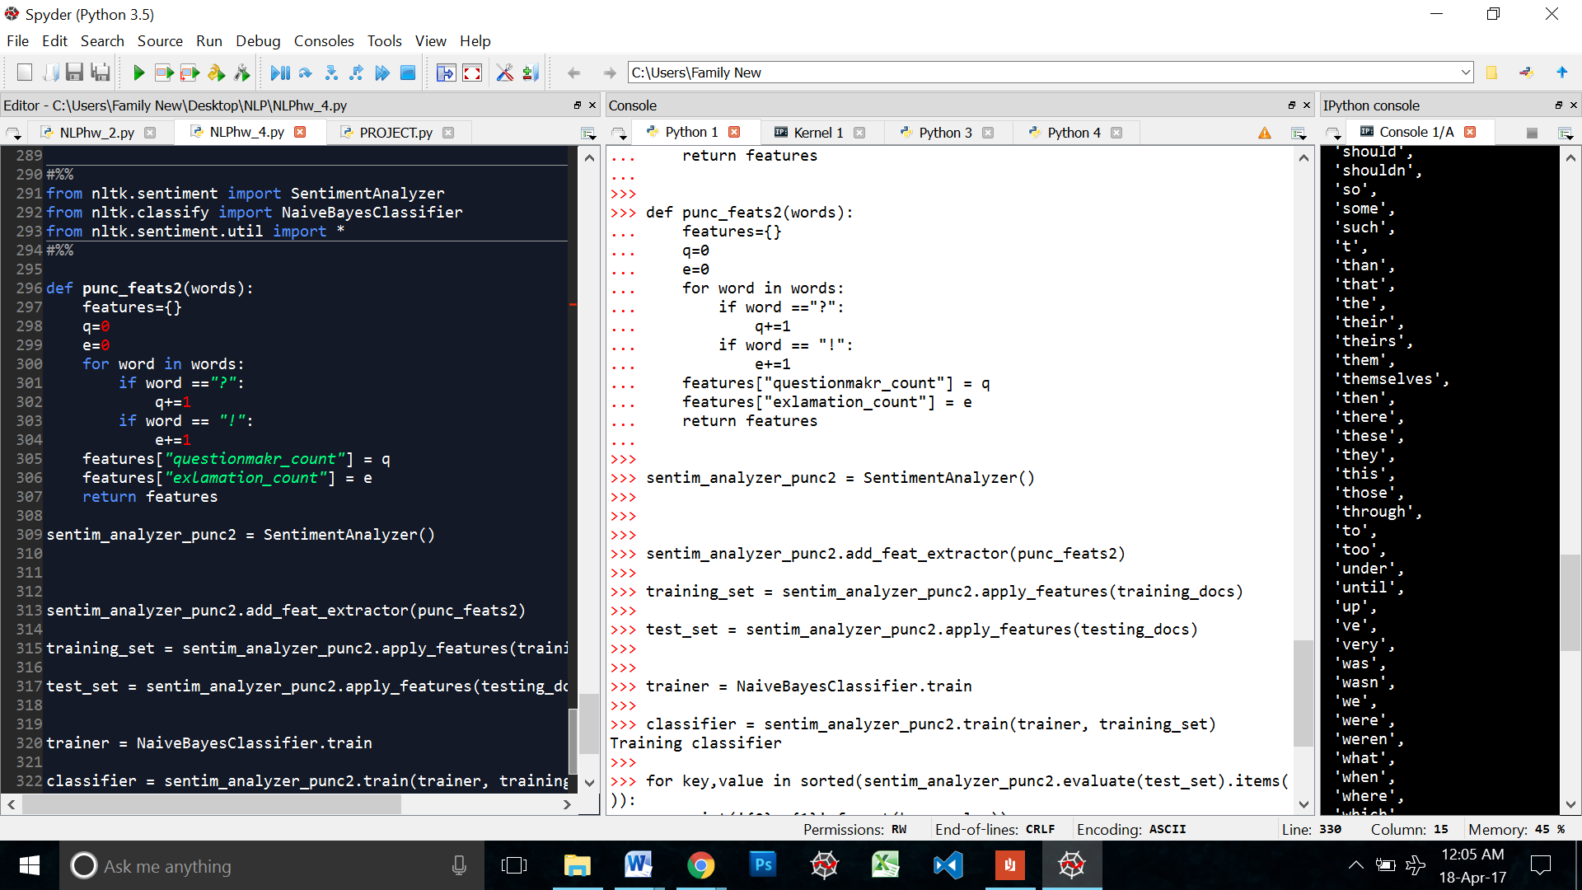

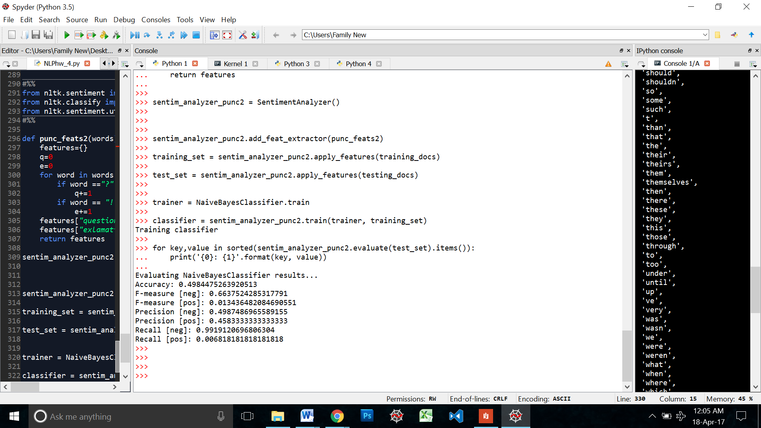

There isn’t much difference. Maybe the Classifier counts the number of individual punctuations in the version 1 of the functions just like what the second version does. I will only be counting the first version.

### Remove Punctuations

This function removes all the punctuations marks from the sentence

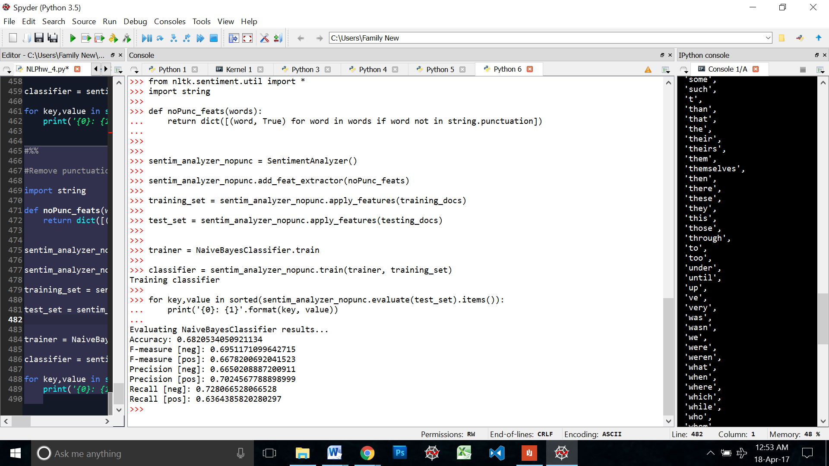

### Adjective Polarity

Using the subjectivity lexicon and the function to read it from class, I wrote a function that would check if the word was an adjective if it was it would calculate that words polarity score and store it in a features dictionary. This feature checks the polarity score of the adjectives in the sentence.

Define the function the read the lexicon from file

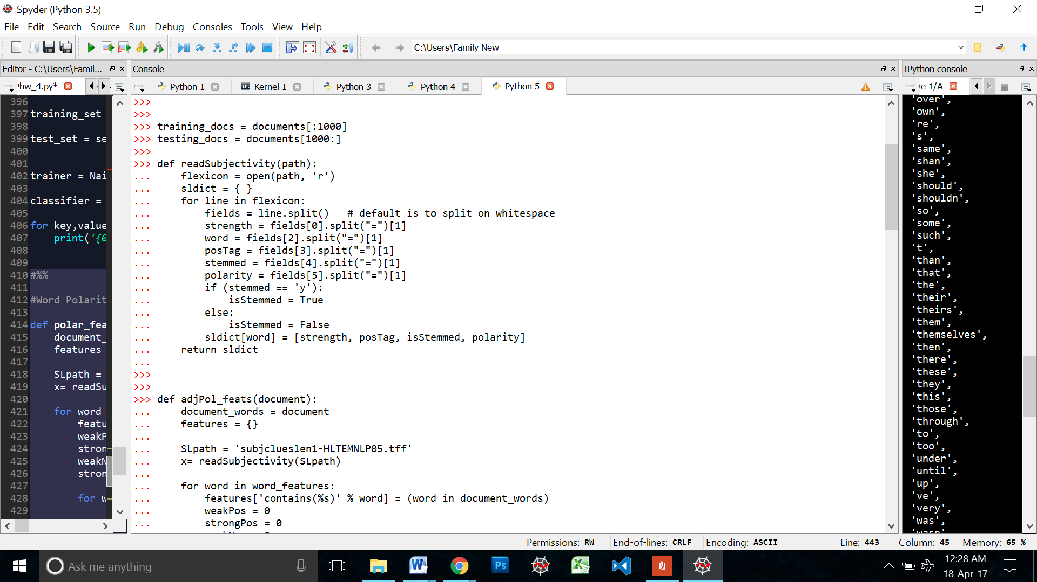

Defining the features function

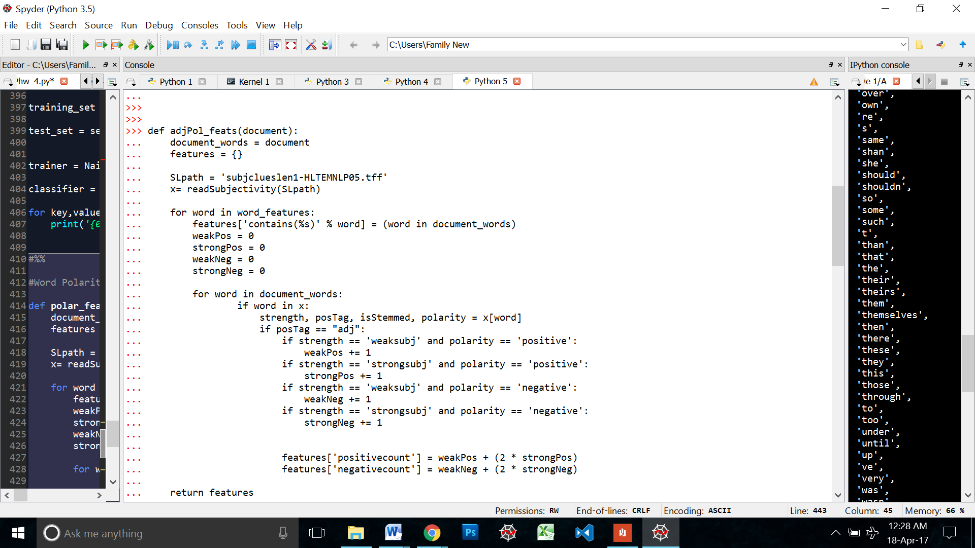

I created a sentiment analyzer object for this feature: sentim_analyzer_adj_pol

Training the classifier on this feature

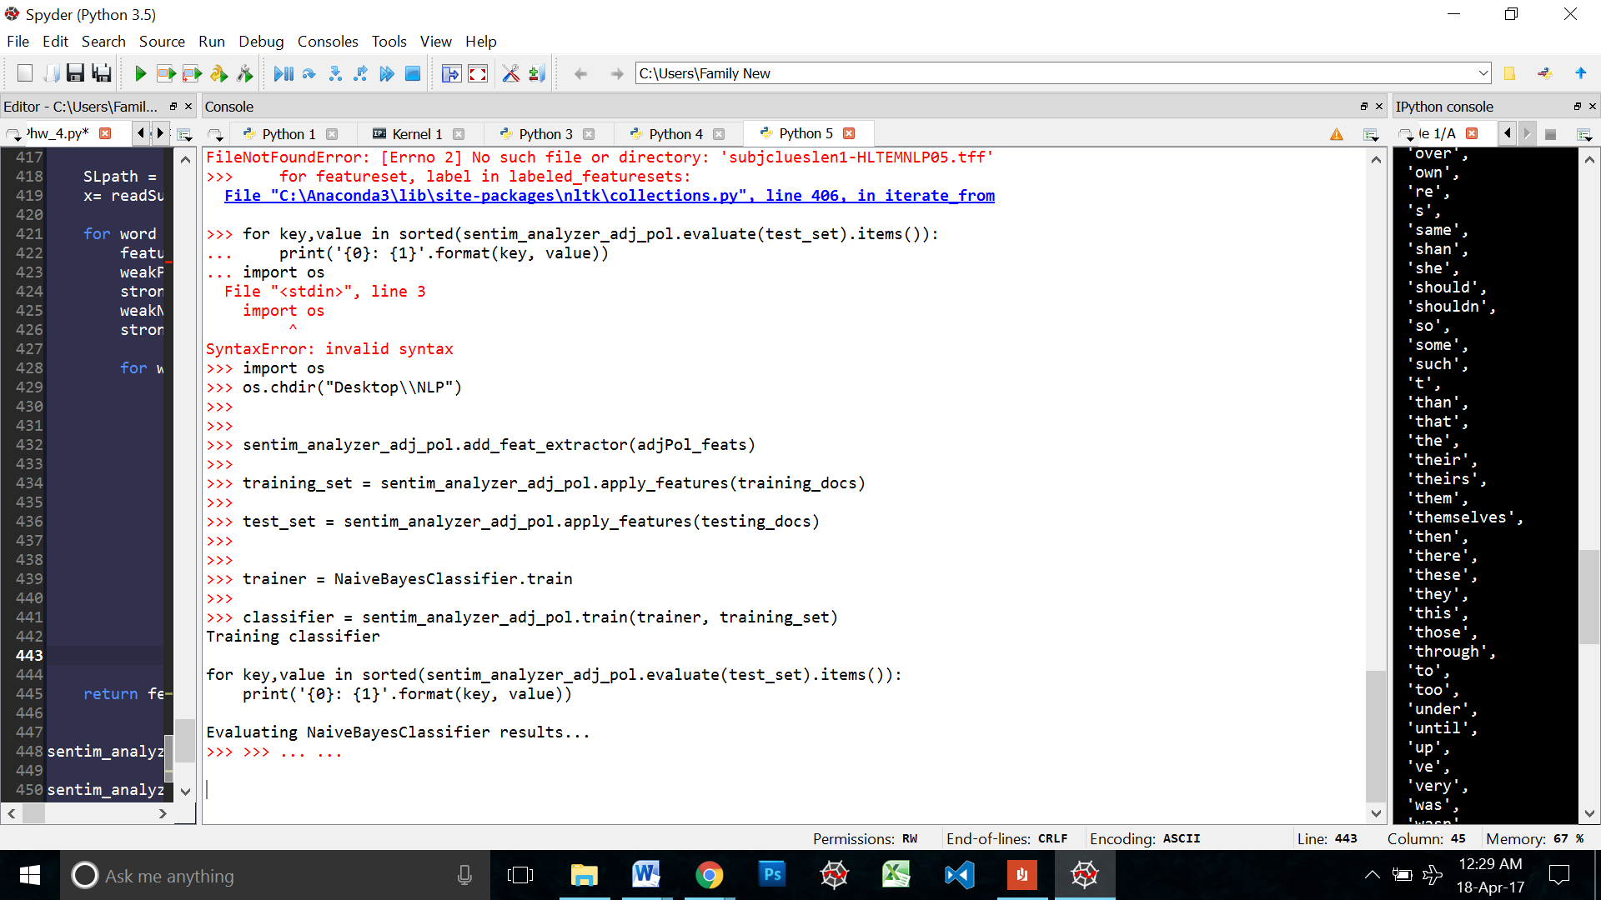

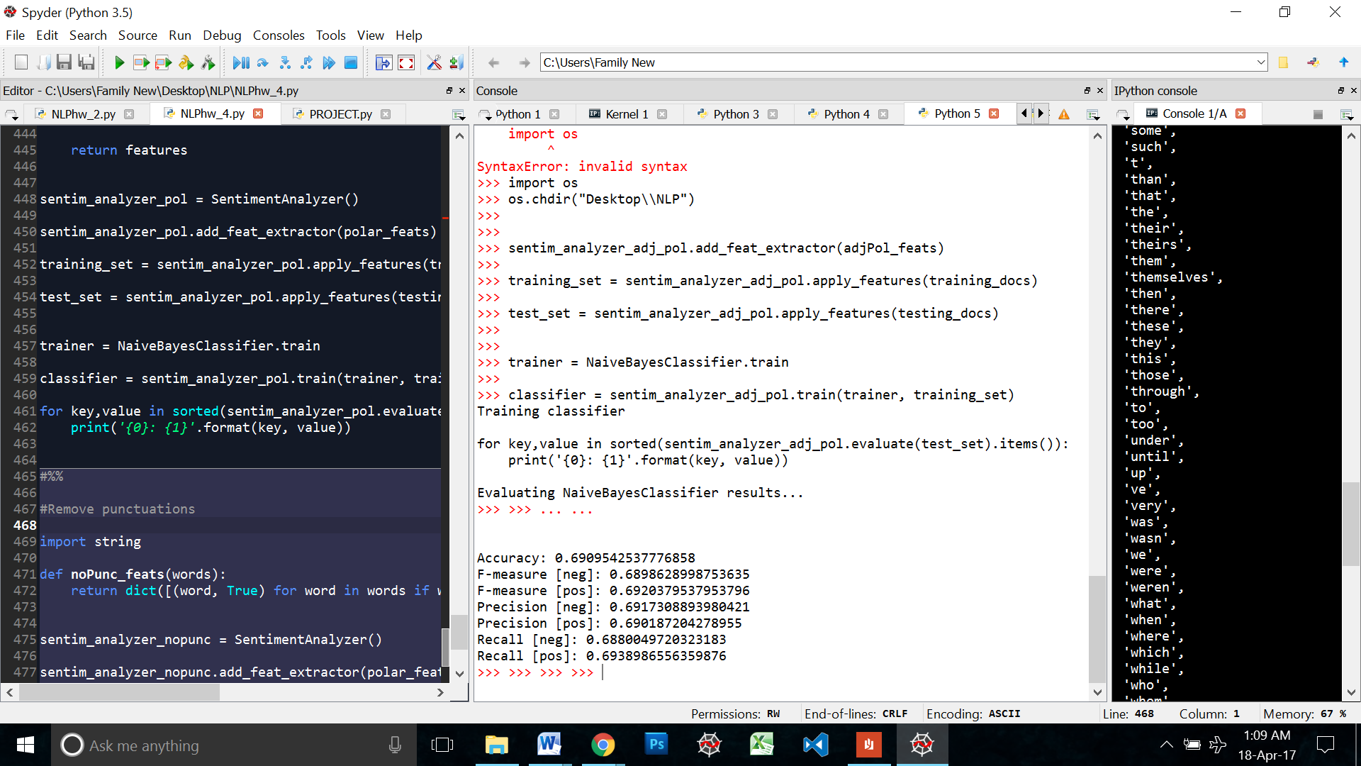

### Word Polarity

This feature checks the word polarity score of all the words in a sentence. It works on the same principal as the previous feature.

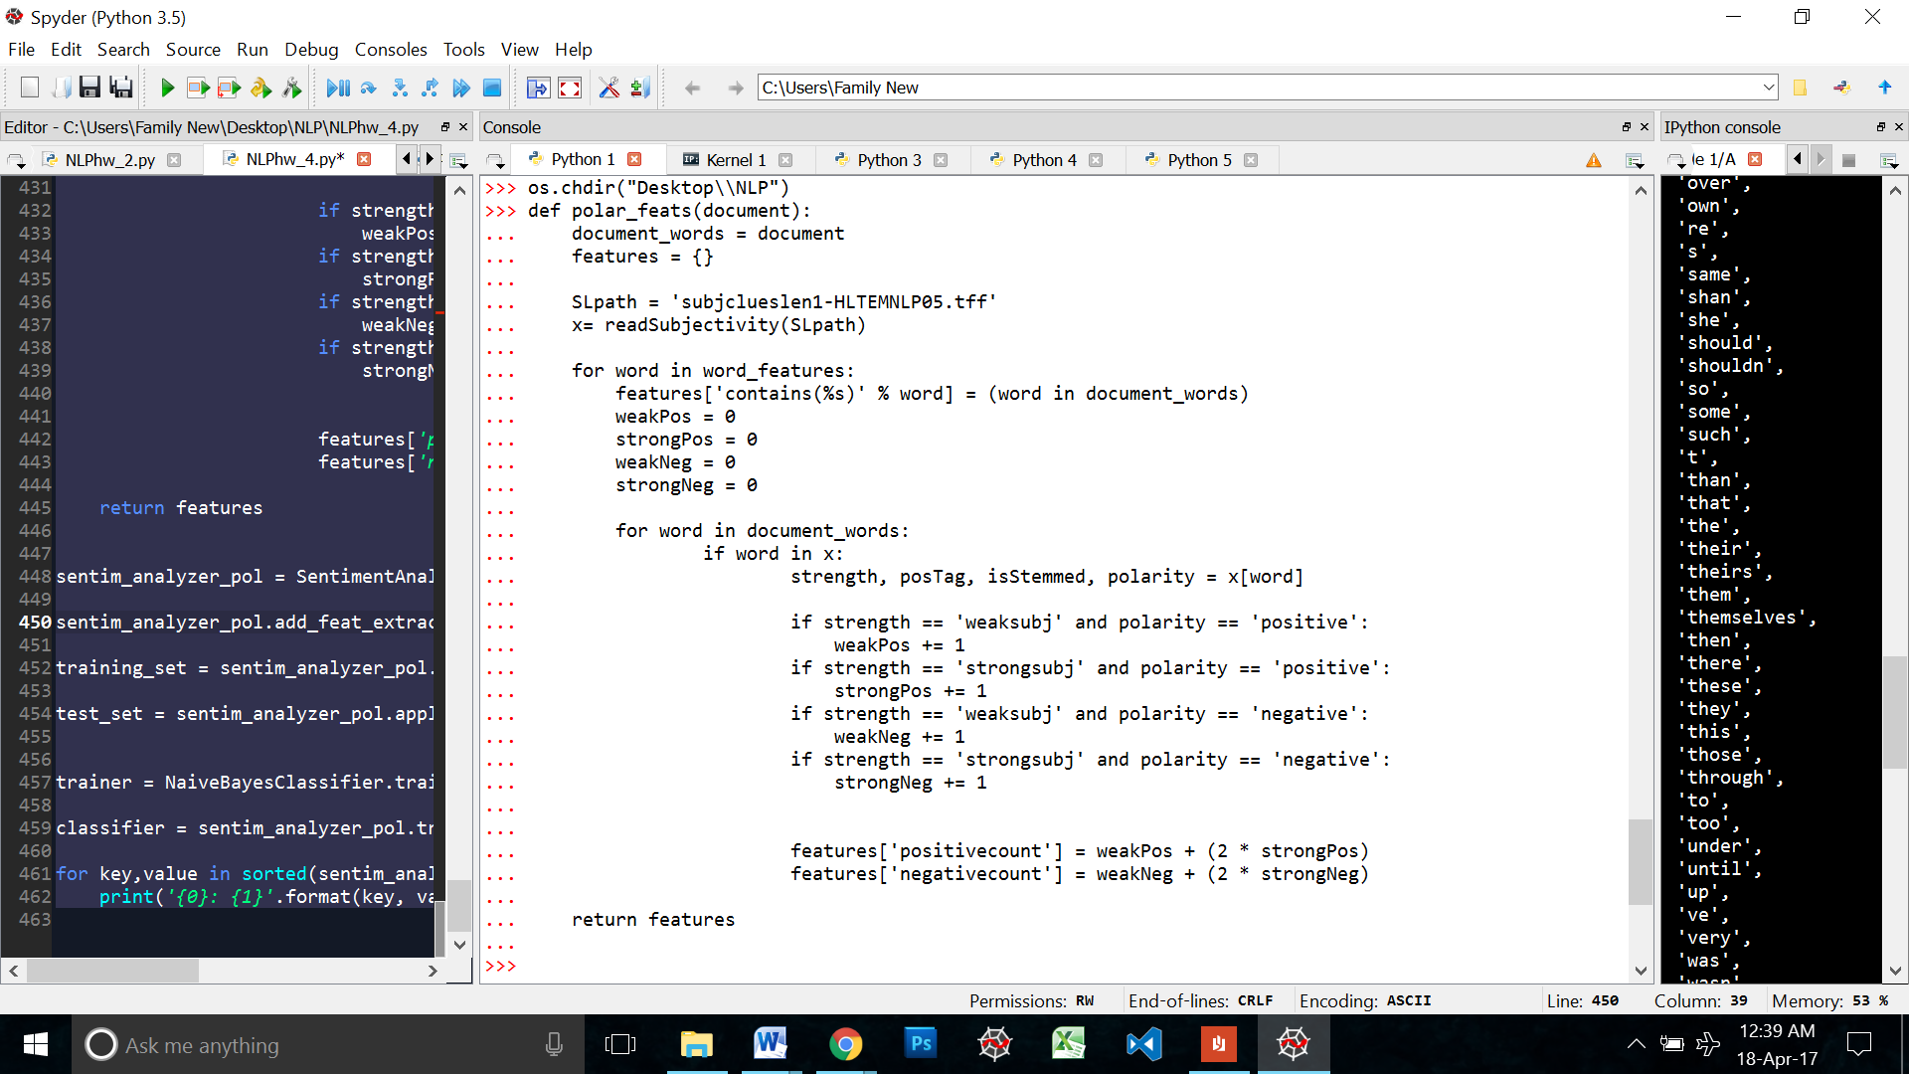

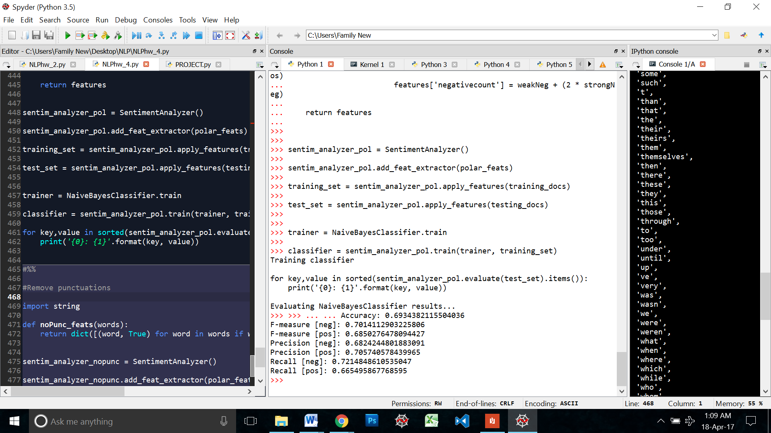

### Noun Polarity

This feature checks the polarity score of all the nouns in a sentence. Like all the previous ones, I created a sentiment analyzer object: **sentim_analyzer_noun_pol**

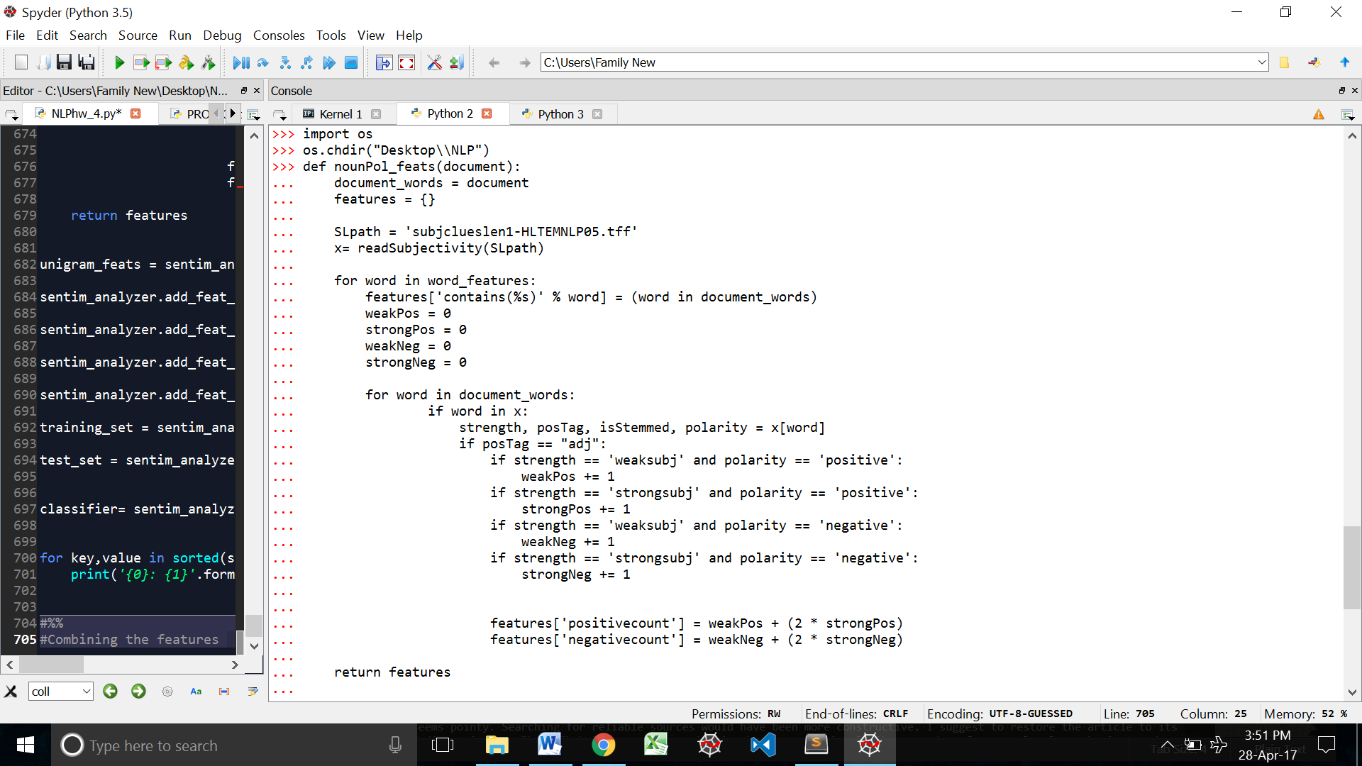

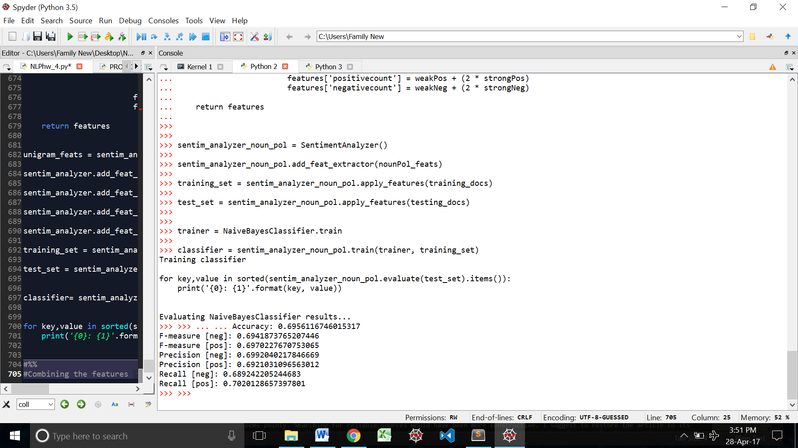

## Comparison

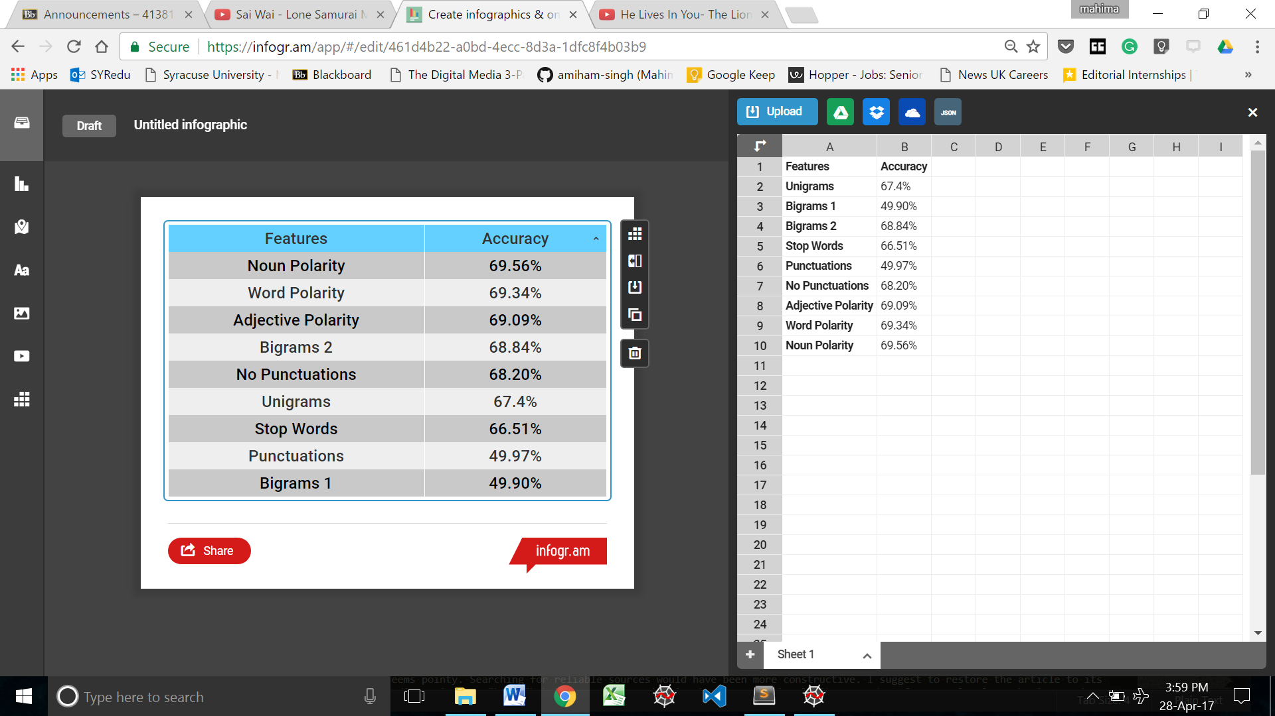

## Combining features

Now that we have a list of features and their accuracies, I started combining the top features to see which yields the best accuracy. Based on these results I will choose my final feature set and the run the Wiki discussion sentences through a classifier training on that feature set.

### Unigram and Stop words

First I created a sentiment analyzer object. I will call both the unigram and stop words features on this object.

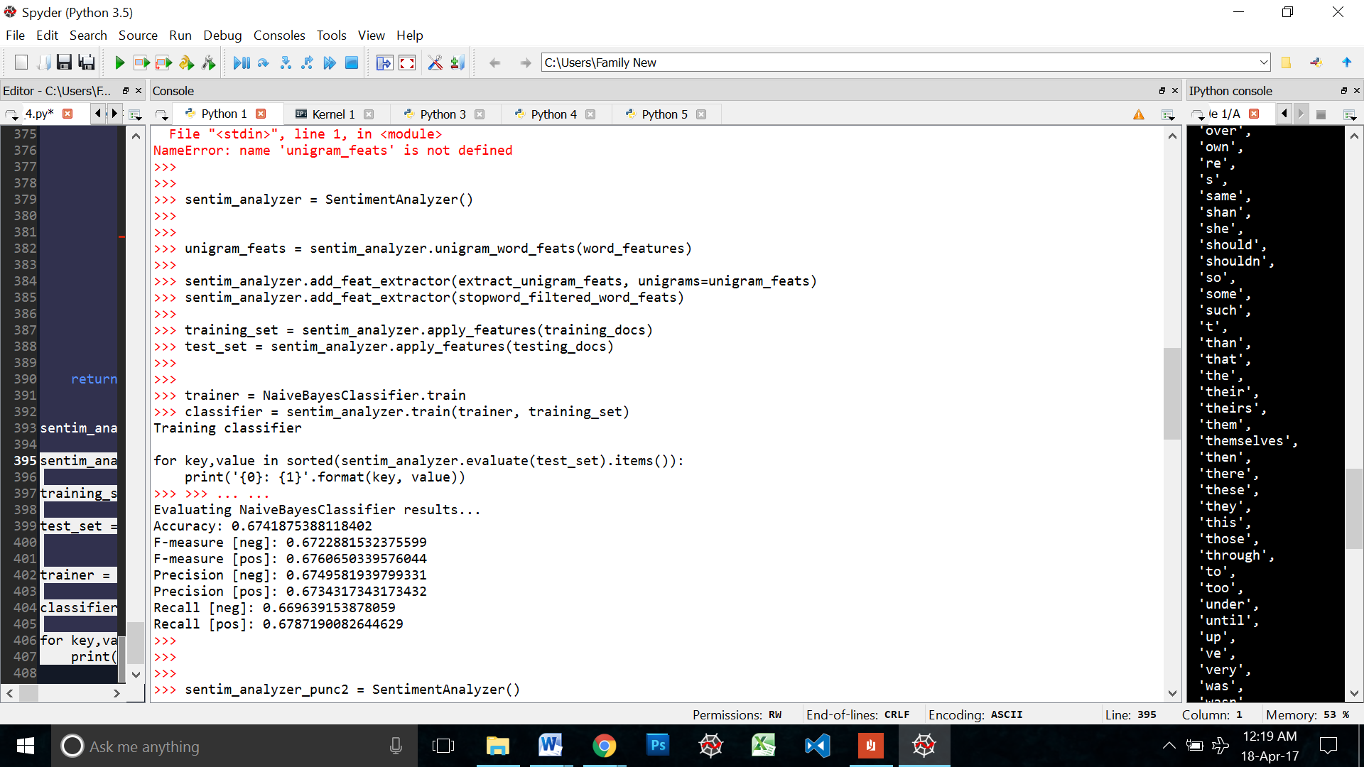

Since both the unigram and stop words functions have been defined I do not need to do it again. I just combine them to the same analyzer with the add_feat_extractor function



Then I train the new analyzer and evaluate the results



### Bigrams and Noun Polarity

Adding the noun polarity feature with the second version of the bigrams feature we get the following:

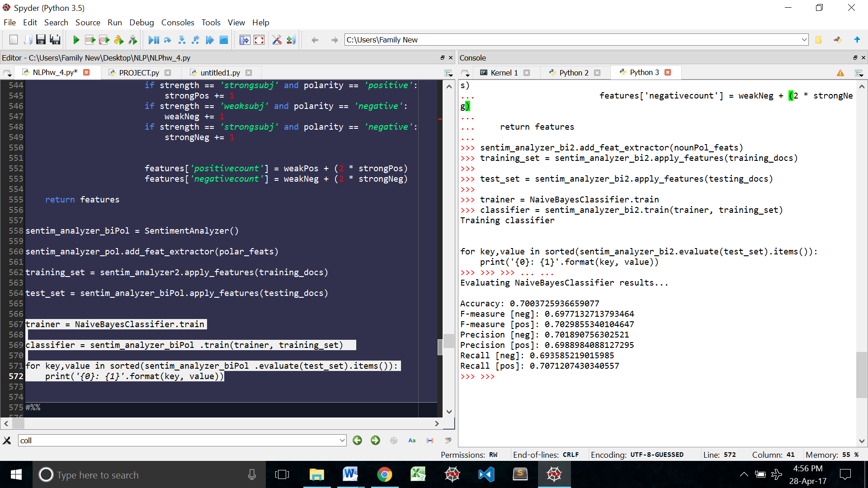

### Bigrams and Word Polarity

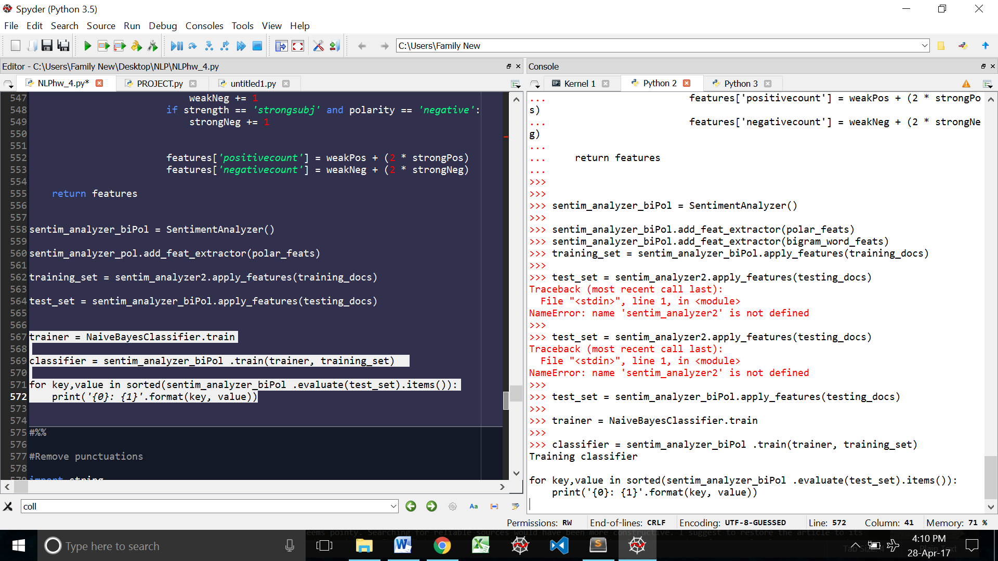

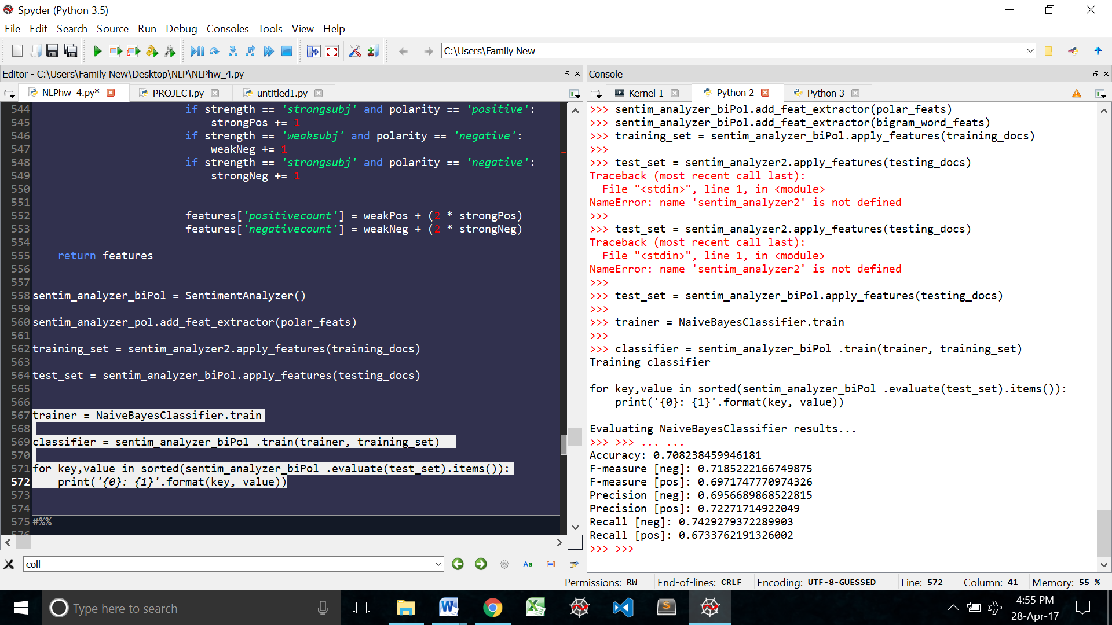

### Bigrams and Adjective Polarity

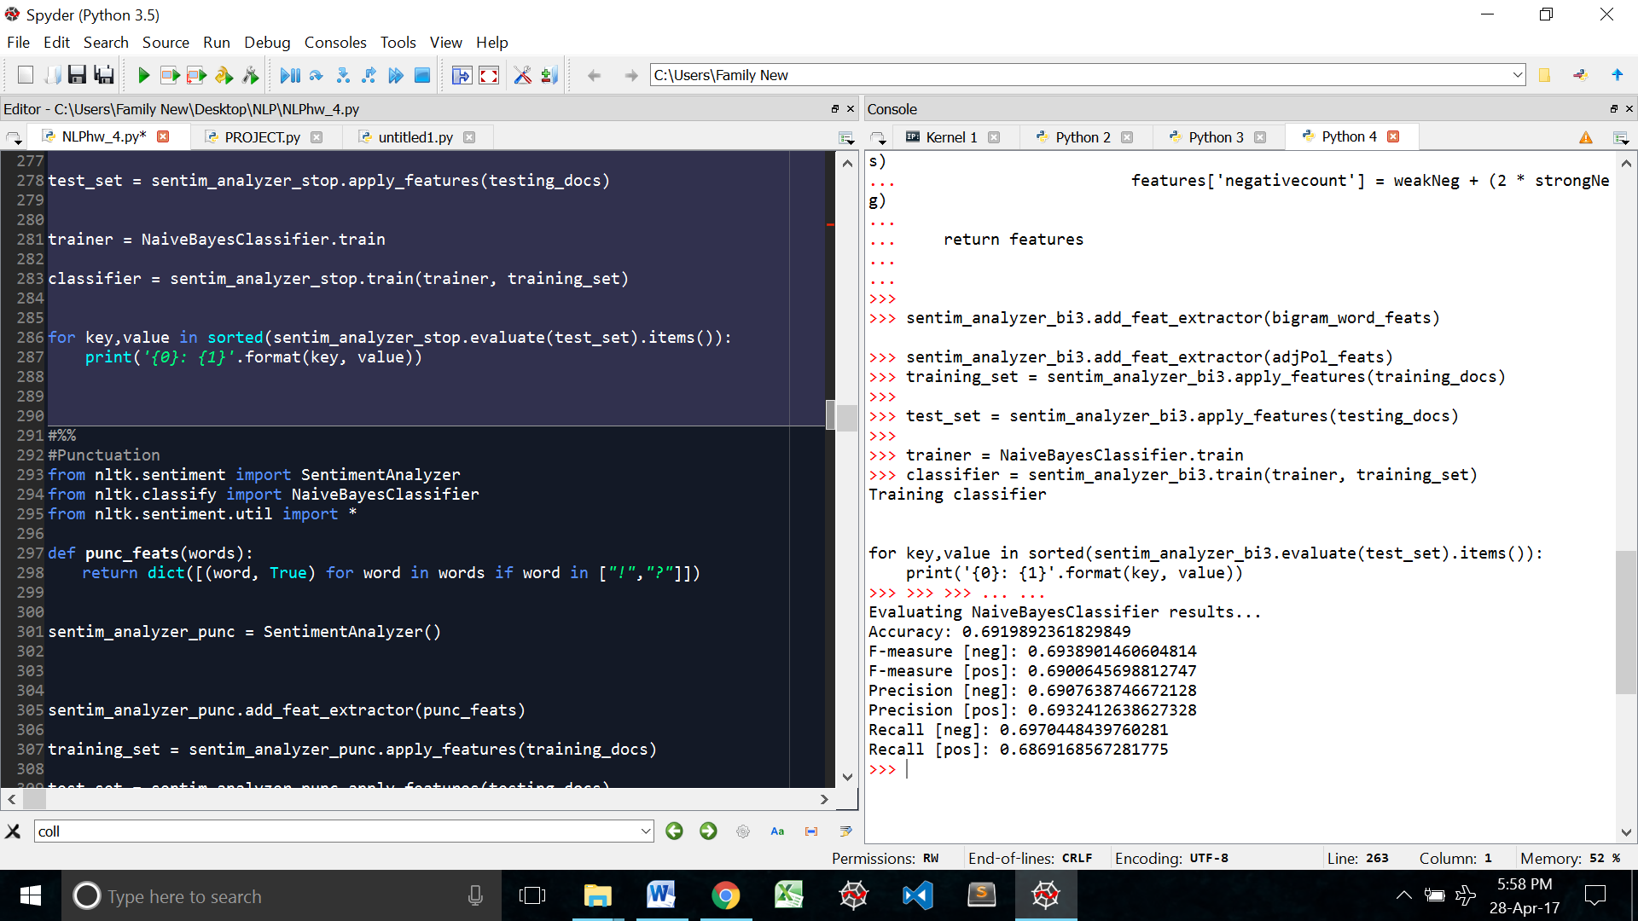

### Stop words and remove punctuations

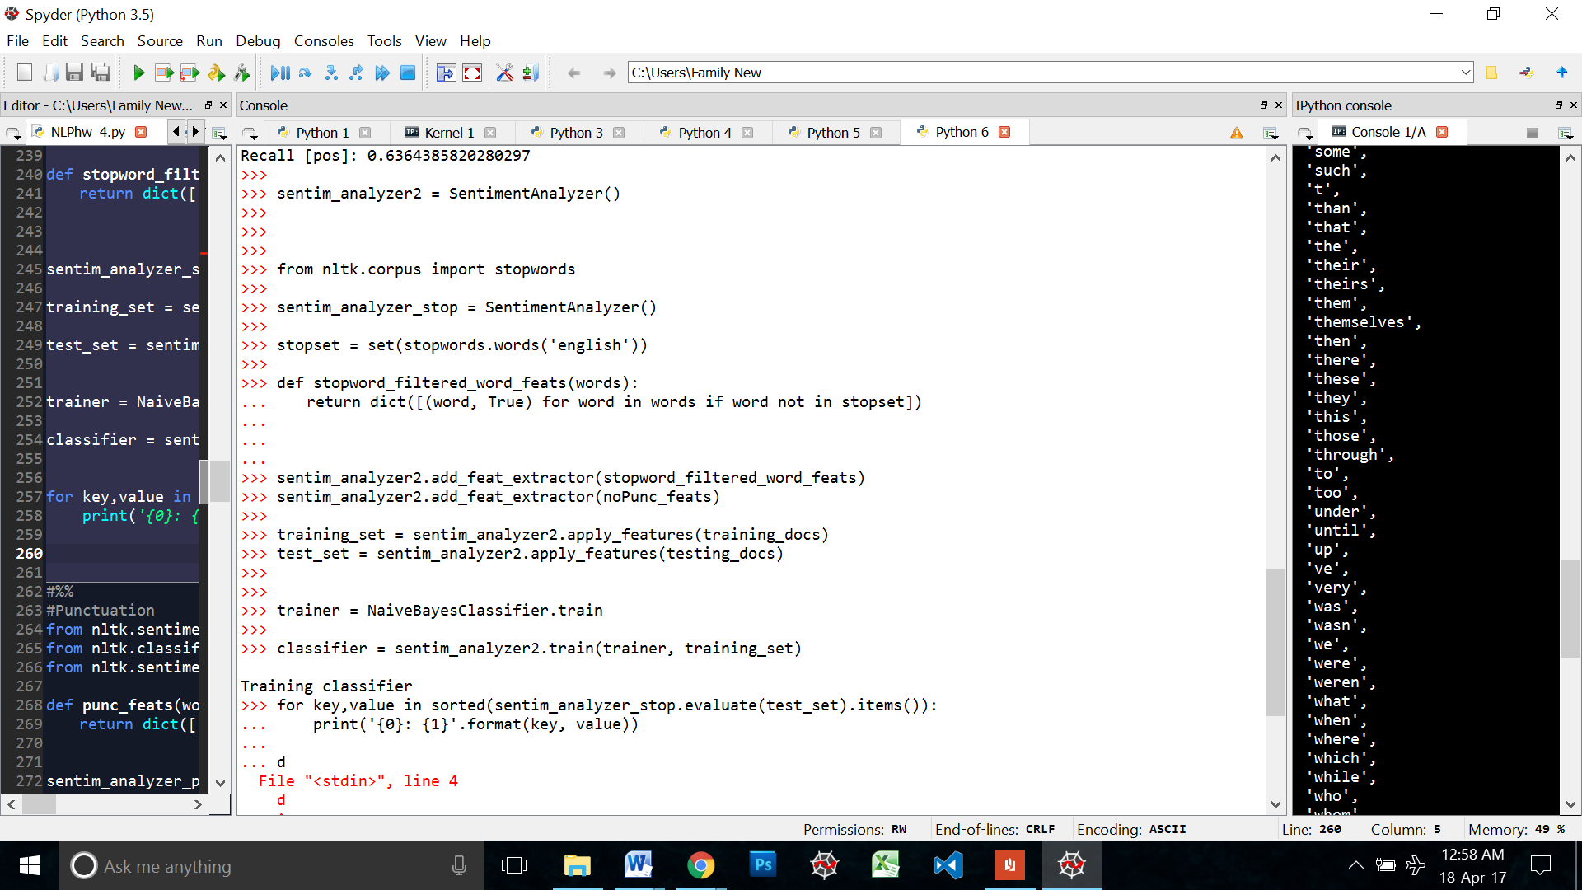

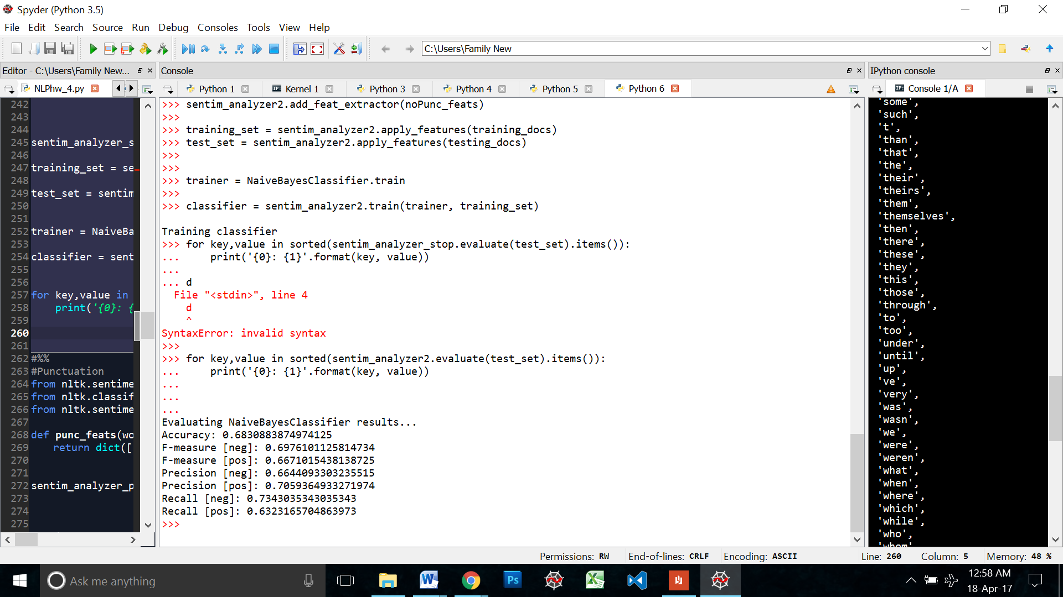

### Unigrams, Stop words and Remove punctuation

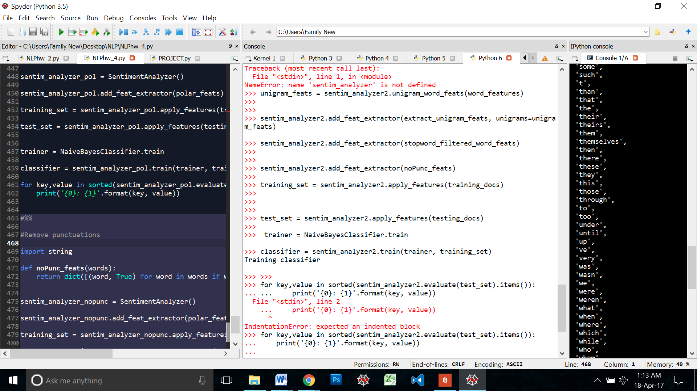

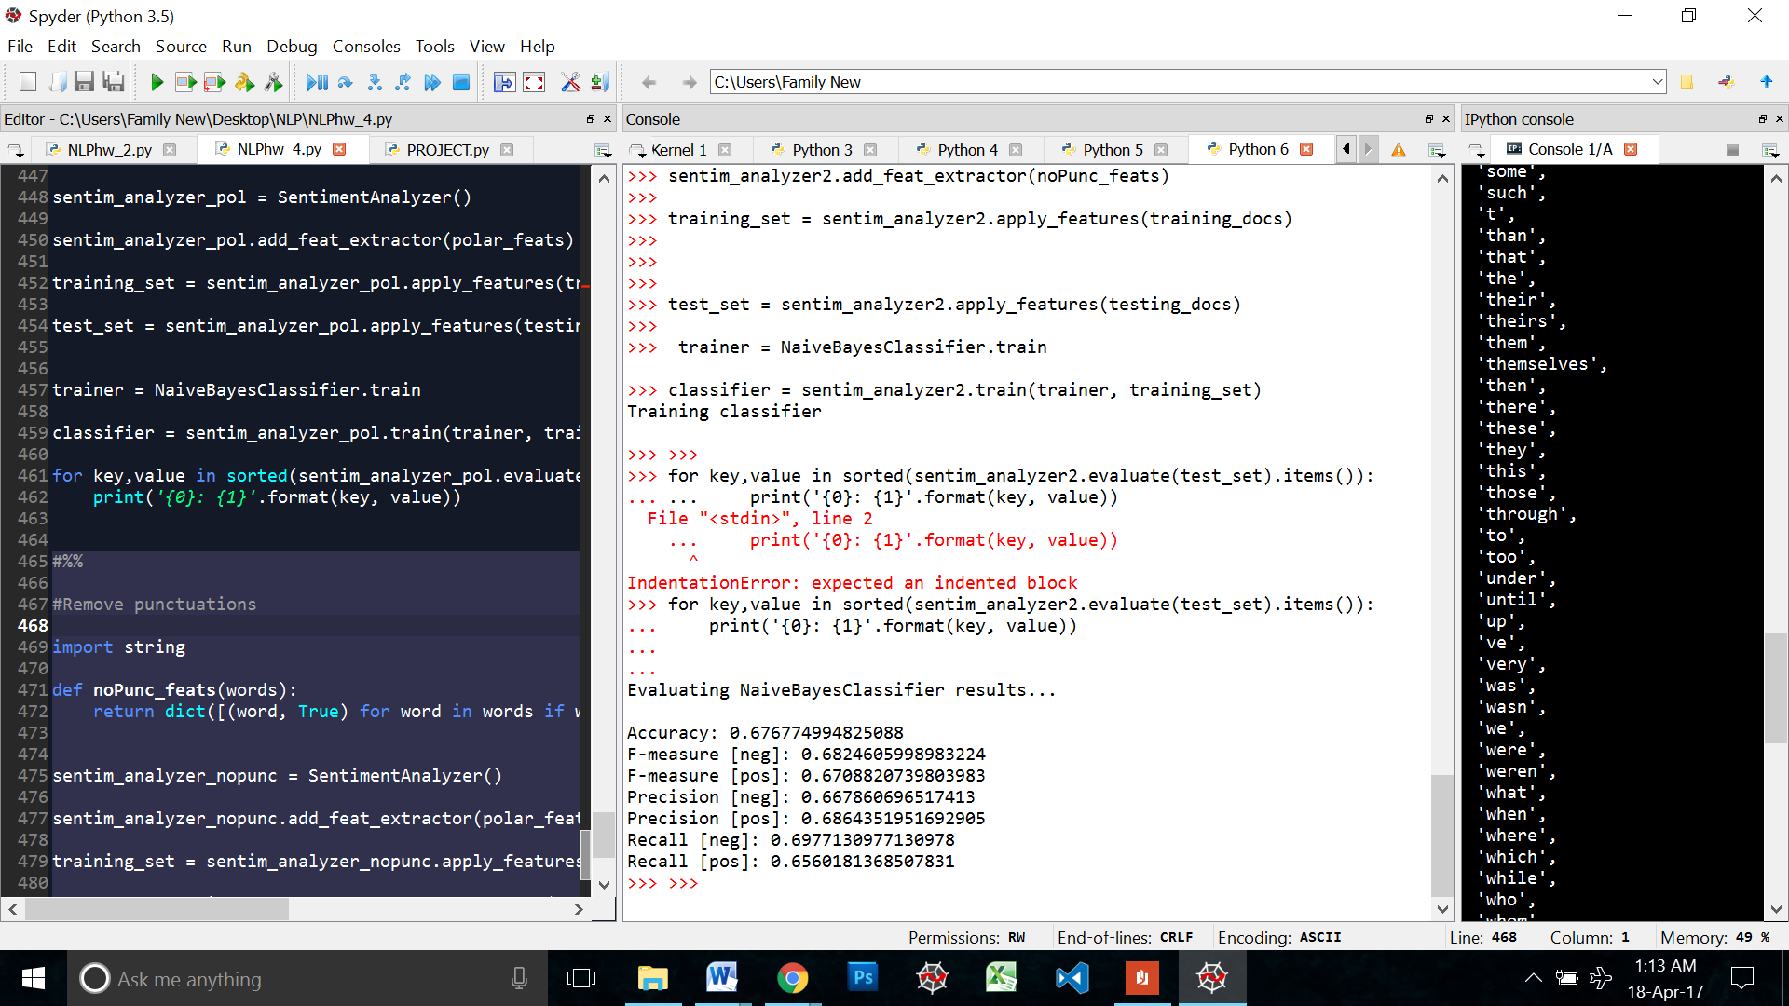

### Final Classifier

After running through various combinations of the top accuracy features the following feature set got the highest accuracy of 70.82%

**Bigrams Version 2 + Word Polarity + Stop words filtered + No punctuations**

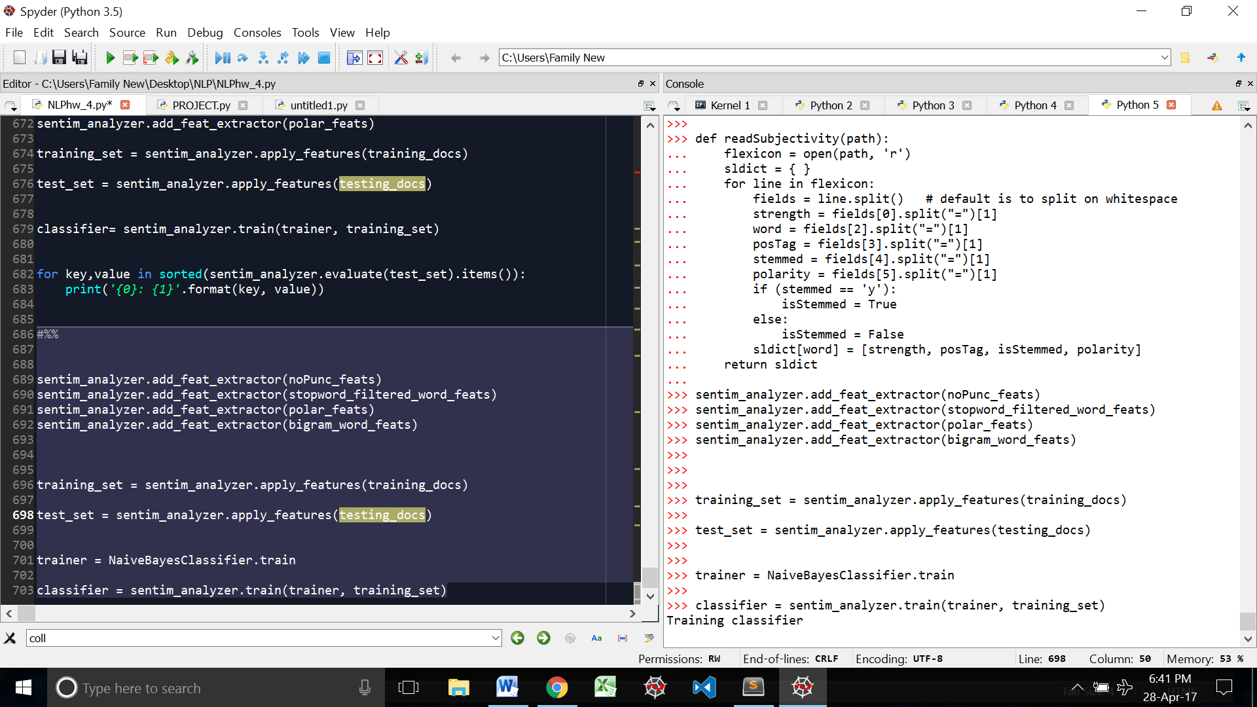

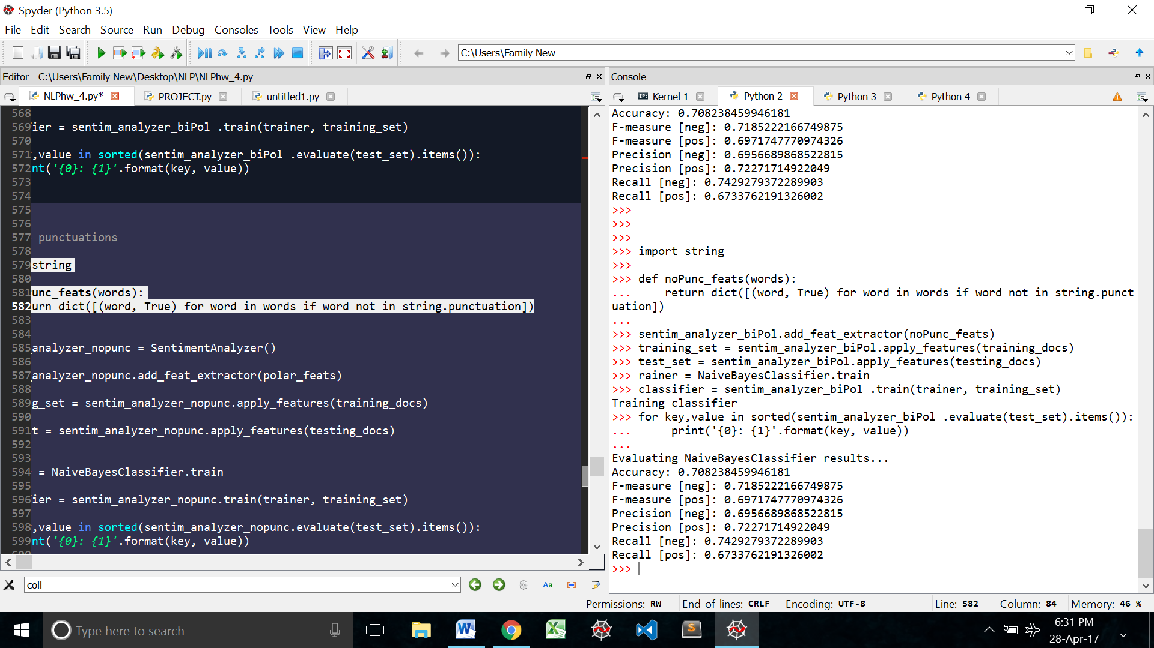

**Classifying the discussion sentences**

Now that we have our final classifier trained. We can move on to classifying the wiki Discussions.

The sentiment analyzer library has a very simple classification function: **Obj.classify(text)**

We will read in each sentence from the sents list that we defined in the starting of this program.

Then we will tokenize it and pass it through the classifier. If the classifier returns ‘neg’ then we will append that particular sentence (not the tokens) the negative list and if the classifier returns ‘pos’ then we will append that sentence to the positive list

Defining out negative and positive lists

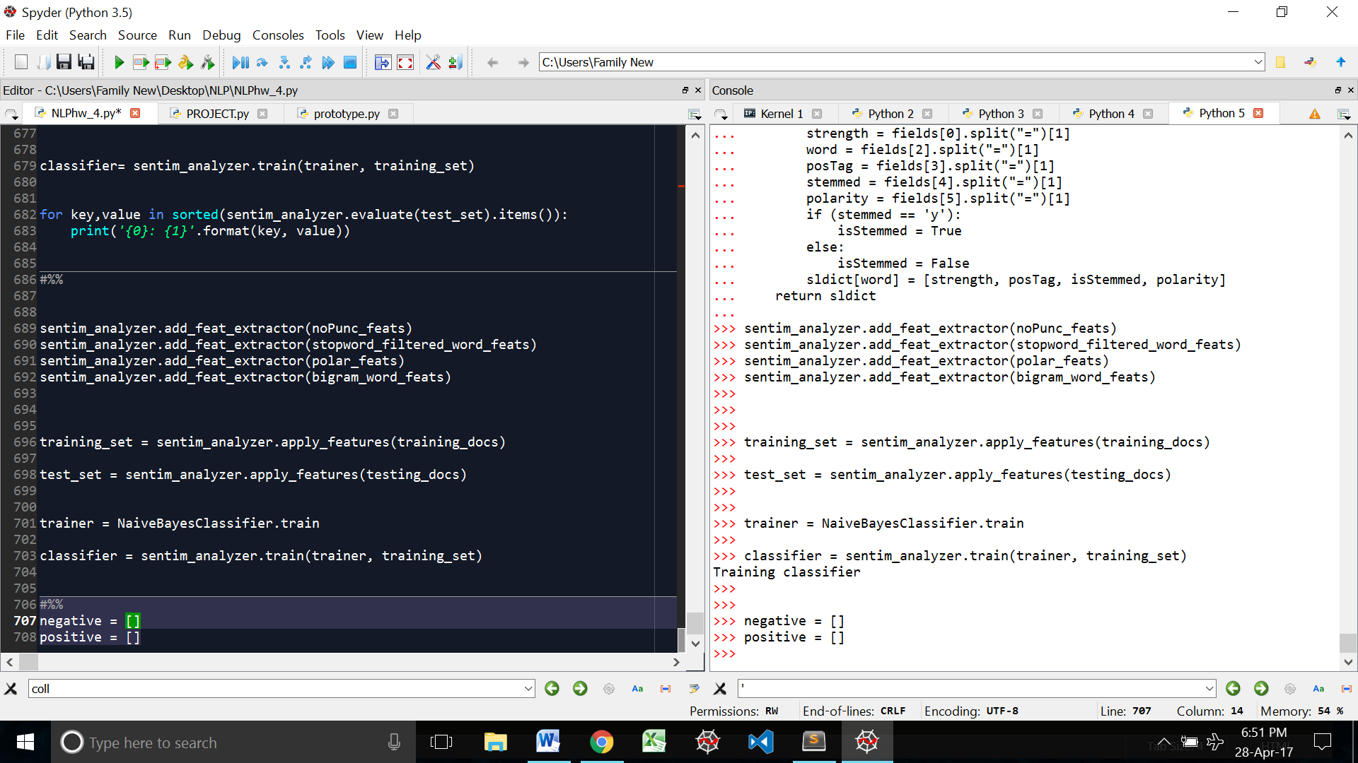

Running each sentence through the classifier and appending the lists

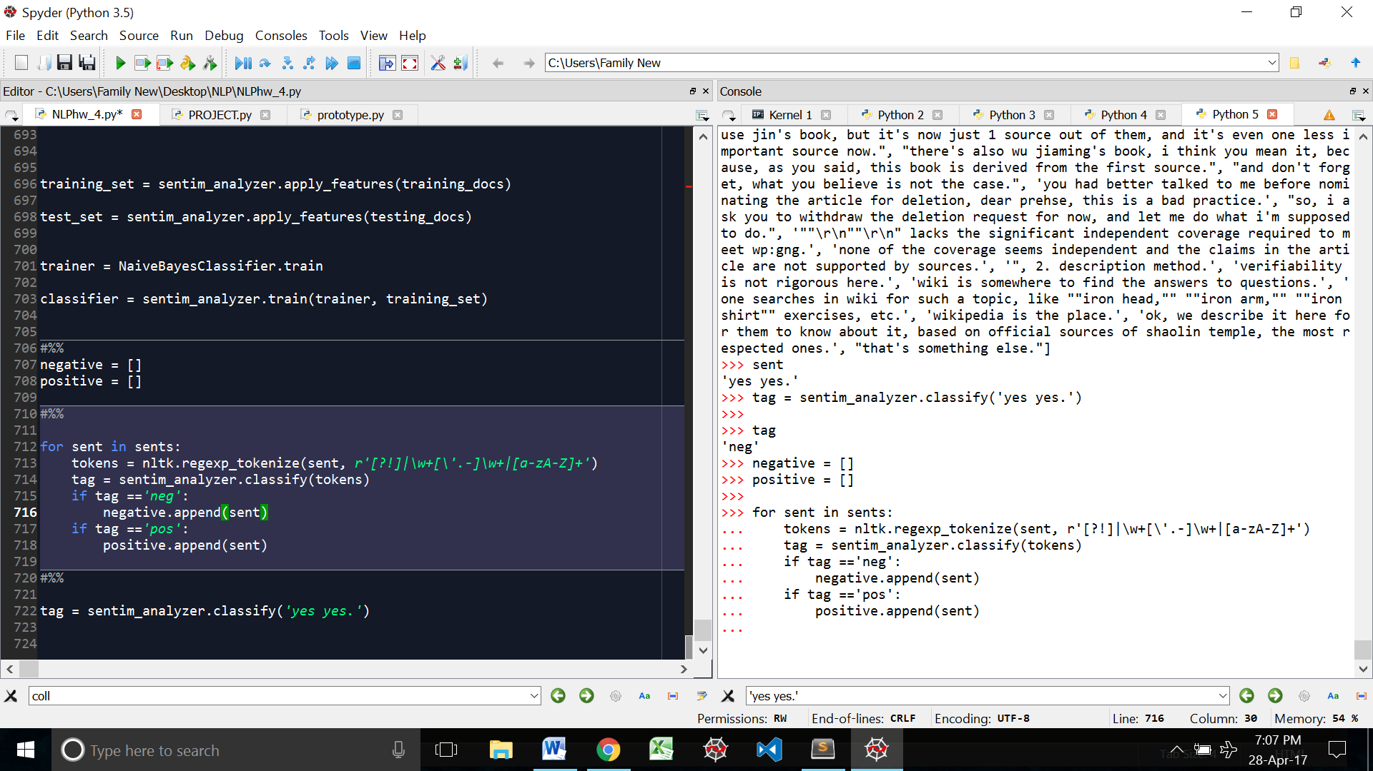

Writing into the file:

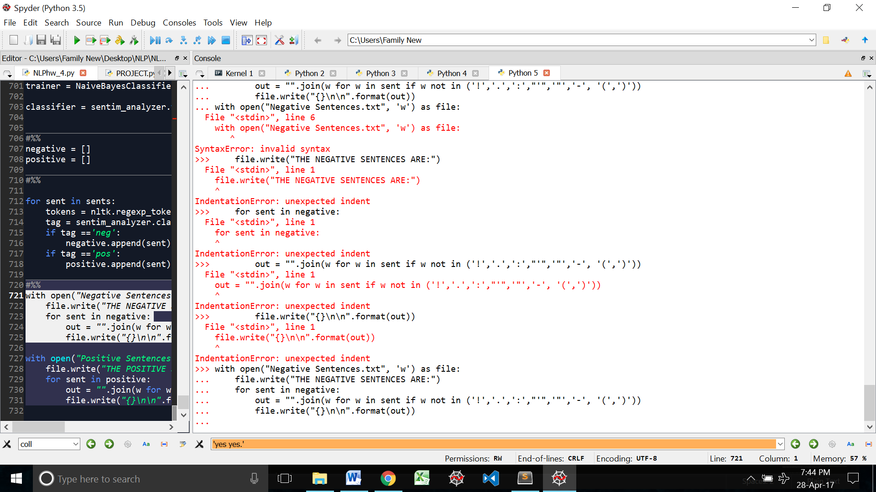

In the above code this statement -

**out = "".join(w for w in sent if w not in ('!','.',':',"'",'"','-', '(',')','~','|',','))**

Takes each word in the sentences and checks to see if it is a punctuation. This part of the code is basically stripping the sentence of punctuations marks

Looking at the final data: 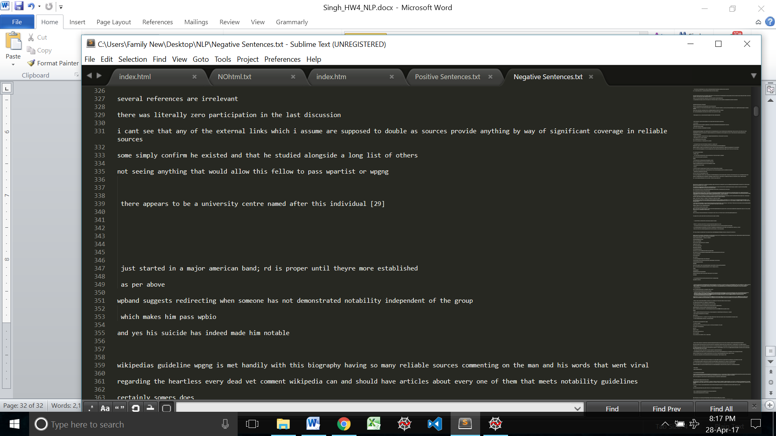

I still can’t get rid of the ‘\r\n’ even after I try saving the file is utf8 encoding.

I even tried joining all the negative sentences

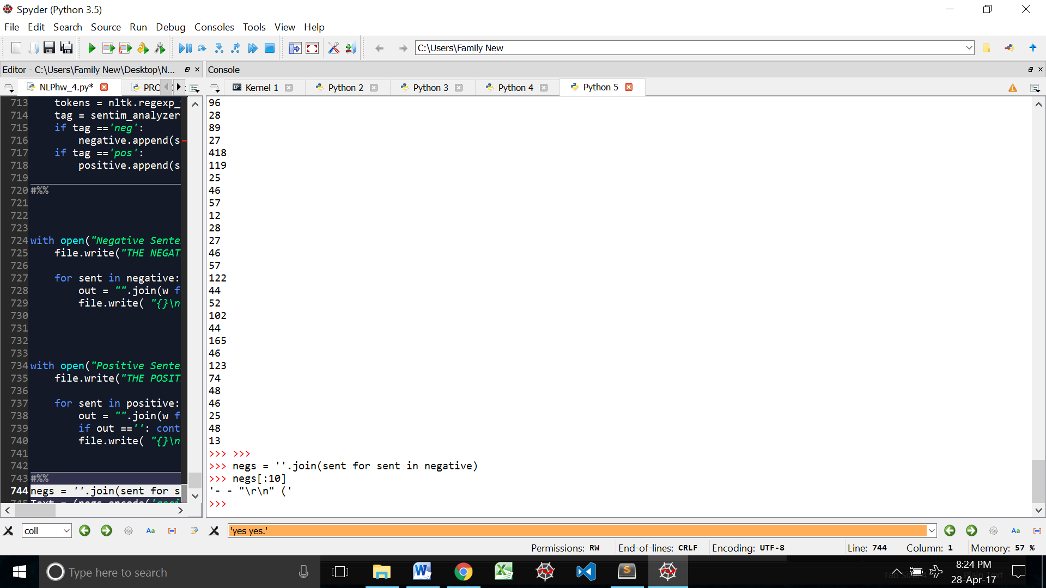

But the escape characters were still there.

When I print the sentences then escape characters get converted into their respective spaces etc.

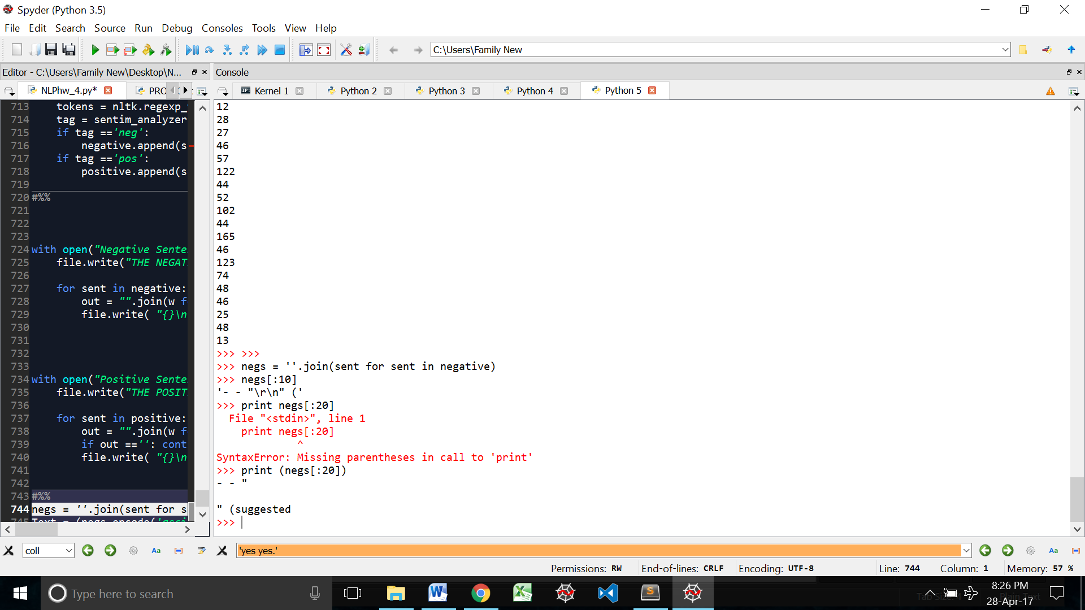

This is what happened in the final output. That is why there are so many spaces and returns in the text files.

I even tried formatting the output file, but the space and new line character couldn’t be cleaned.

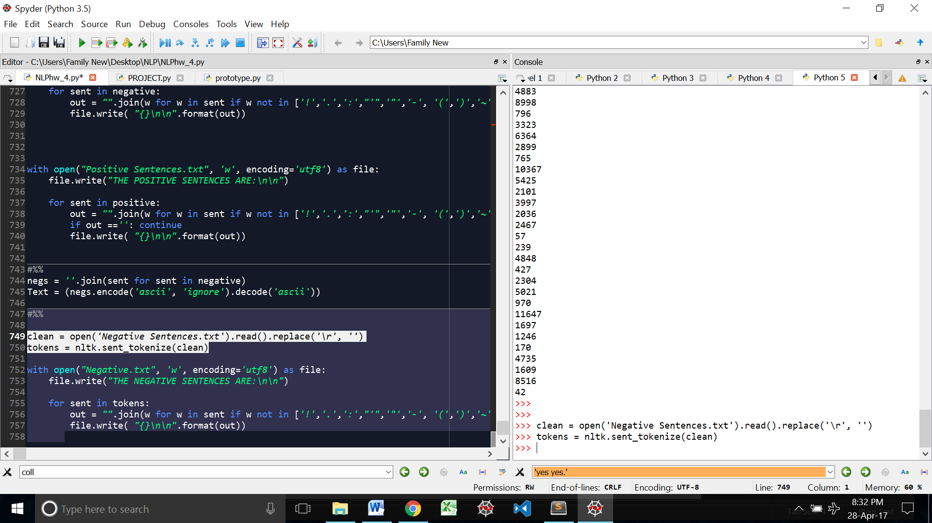

I took the text from the ‘clean’ and copy pasted it into an empty text file. Then I manually found and replaced the \r\n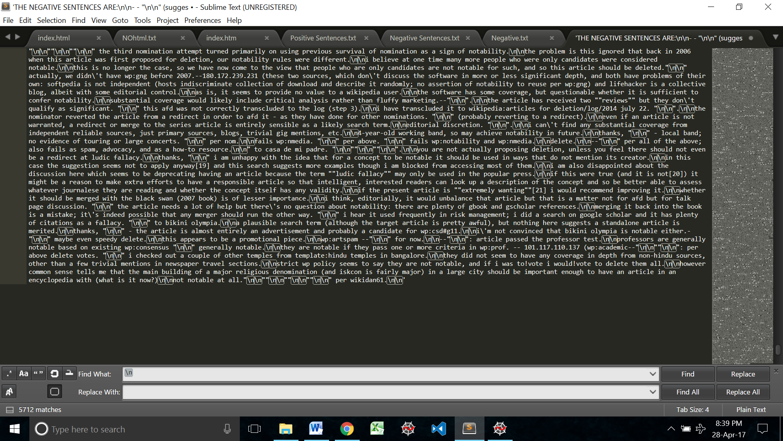

I then saved the file and read it into python and then sentences tokenized it and read it into another file.

Despite me manually taking out the escape characters, it produced the same results.